一念菩提 | 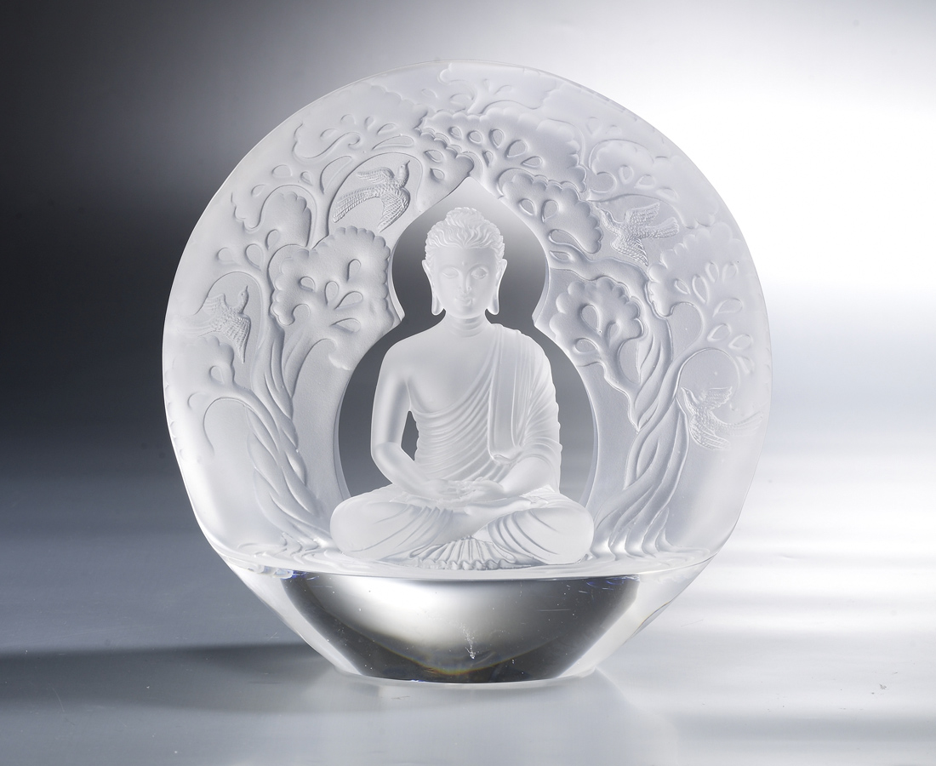
一念生滅 大悲心起
一念無有 大光明境
花開見佛 常樂我淨

Thoughts of Bodhi (Enlightment)
Change your views and set aside prejudices and obsessions. Achieve a wider perspective and feel the joys of blossom and prosperity along with the Universe.

編號 | 1213297 | No | 1213297
名稱 | 一念菩提 | Name | Thoughts of Bodhi (Enlightment)
顏色 | 透(噴砂) | Color | clear (sand blasting)
尺寸 | 11.8 * 20 * 20 | Size | 11.8 * 20 * 20
重量 | 2.5 | Weight | 2.5
限量 | O | Limited Edition | O
售價 | NT$ 24800 | Price | NT$ 24800
 | RMB$ 5510 |  | RMB$ 5510

