大自在 | 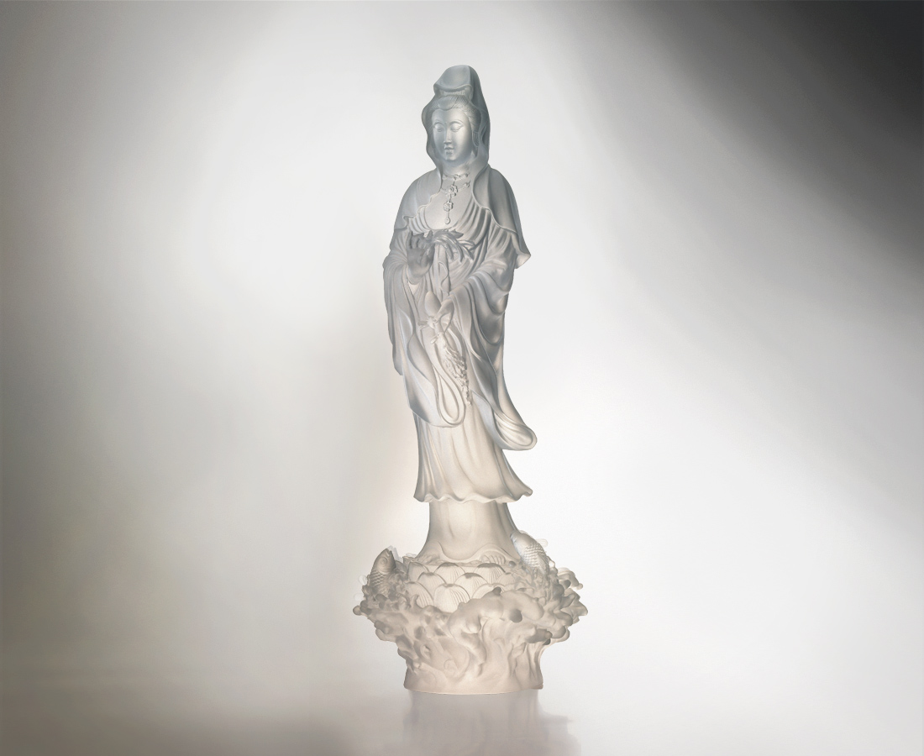
楊枝拂動 無垢無痕
心如明鏡 大自在
淨水遍灑 慈悲護佑
悠游四海 大無畏
Composed Thy Heart
A flick of willow twig, done with trifle, away with sorrow When heart is mirror clean, life at ease, mellow and serene Sprinkles forth the sacred dew, mercy and blessings to all of you To four seas the sailing starts, gone with fear in the enlightened heart

編號 | 1212733 | No | 1212733
名稱 | 大自在 | Name | Composed Thy Heart
顏色 | 透 | Color | clear
尺寸 | 15 * 15.5 * 40.3 | Size | 15 * 15.5 * 40.3
重量 | 4.46 | Weight | 4.46
限量 | O | Limited Edition | O
售價 | NT$ 98900 | Price | NT$ 98900
 | RMB$ 24480 |  | RMB$ 24480

