法無邊 | 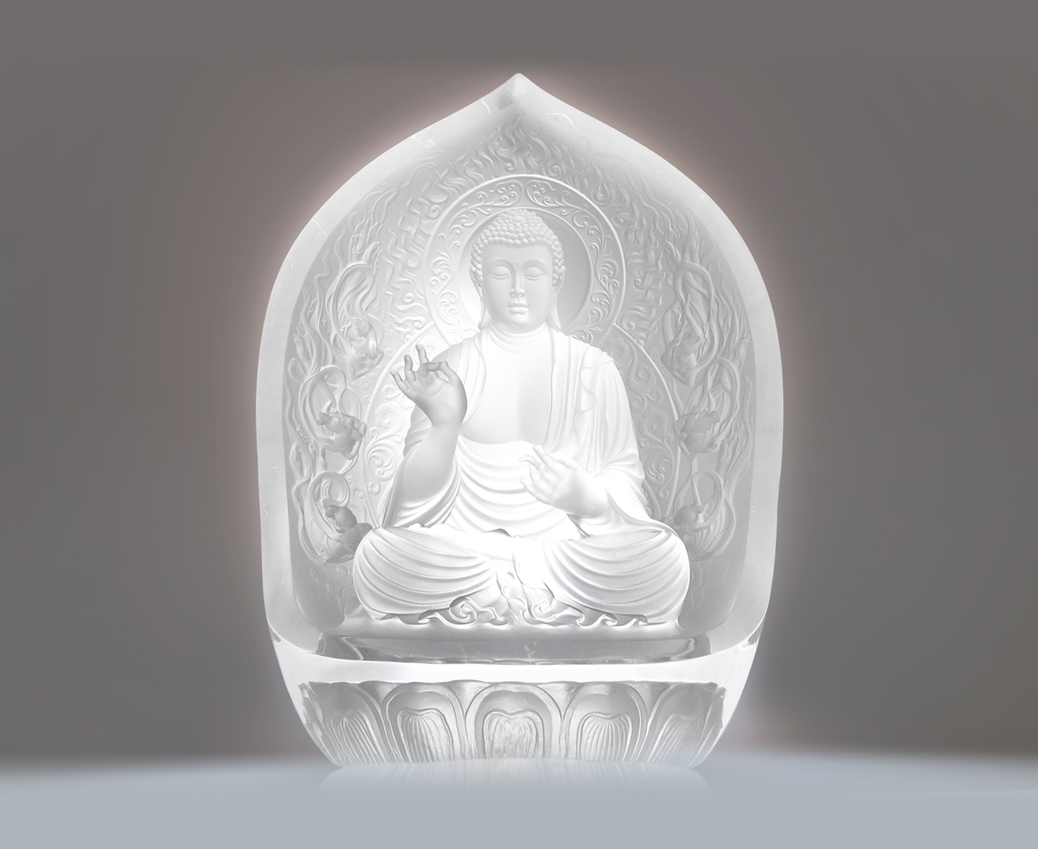
心 清涼世界
照 慈悲光明
The Way Without End
In the heart Where no trace to be tarnished It is cool and refreshed Of the mind Where bias is rid of and self is just Then unto others shed mercy

編號 | 1212691 | No | 1212691
名稱 | 法無邊 | Name | The Way Without End
顏色 | 透 | Color | clear
尺寸 | 32 * 46.4 * 60.5 | Size | 32 * 46.4 * 60.5
重量 | 70.0 | Weight | 70.0
限量 | O | Limited Edition | O
售價 | NT$ 1780000 | Price | NT$ 1780000
 | RMB$ 413960 |  | RMB$ 413960

