菩提大願 | 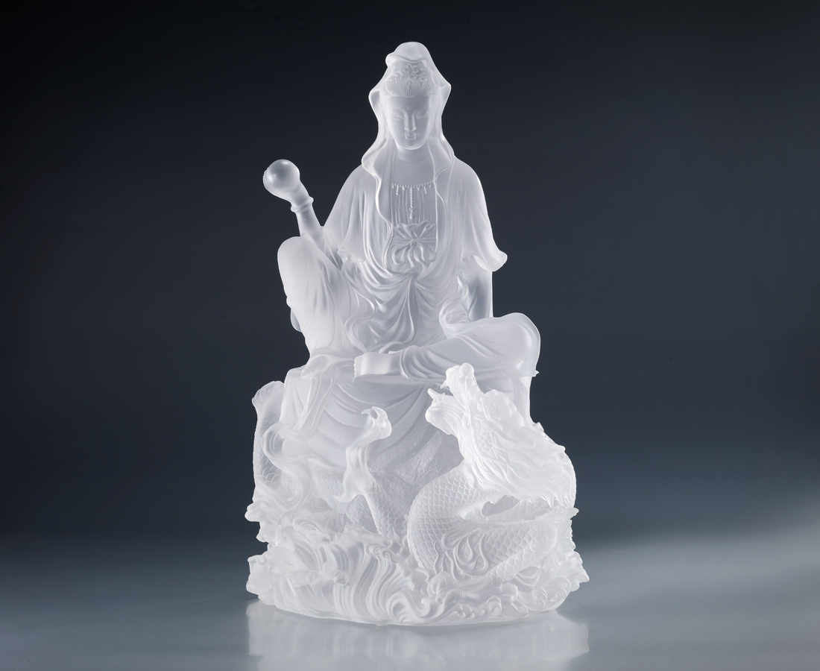
發慈悲願 到無限大
照智慧光 到無限遠
A Grand Wish Of Bodhi
That an oath of mercy, spreads on and on That wisdom of kindness, shines far and beyond

編號 | 1212664 | No | 1212664
名稱 | 菩提大願 | Name | A Grand Wish Of Bodhi
顏色 | 透 | Color | clear
尺寸 | 28.5 * 25 * 39.5 | Size | 28.5 * 25 * 39.5
重量 | 17.4 | Weight | 17.4
限量 | O | Limited Edition | O
售價 | NT$ 107760 | Price | NT$ 107760
 | RMB$ 22460 |  | RMB$ 22460

