悠然慈航 | 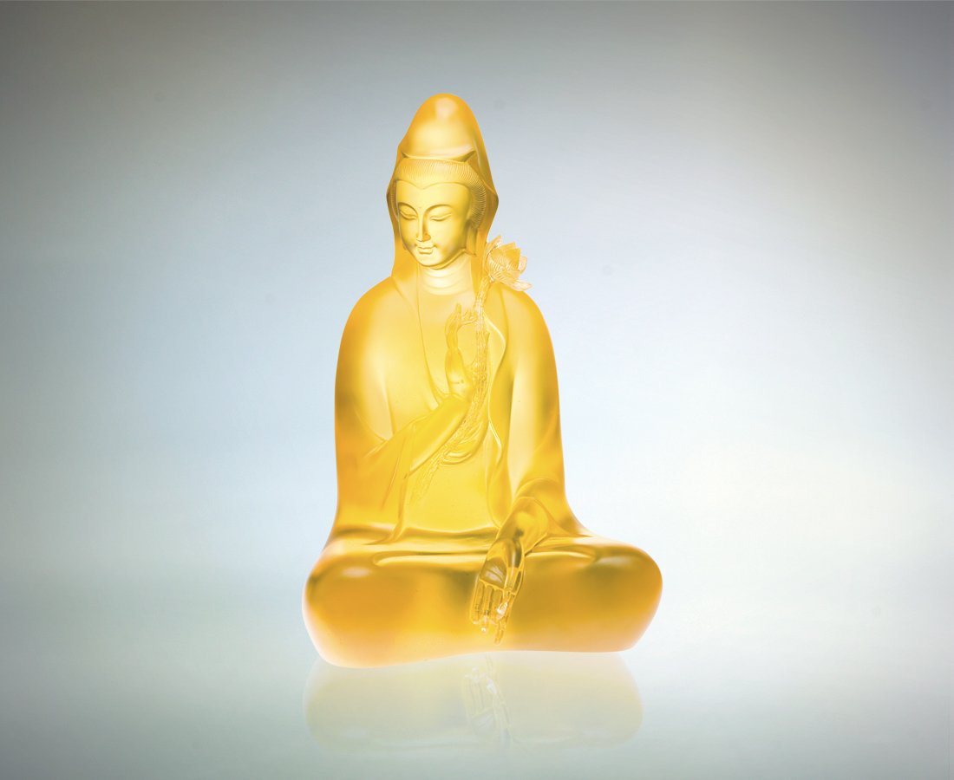
向上
照見慈悲 幽香見佛
向下
觀音大願 喜捨見性
福慧雙修 同體大愛
慈航普渡 光明遍在
Smooth Sailing
Look up To gaze in awe at the compassionate and Gentle Buddha Look down And admire the benevolent Goddess of Mercy Reap endless blessing and good fortune from a single form Sailing smoothly, emanating brilliance

編號 | 1212298 | No | 1212298
名稱 | 悠然慈航 | Name | Smooth Sailing
顏色 | 金 | Color | Golden
尺寸 | 19.9 * 21.5 * 33 | Size | 19.9 * 21.5 * 33
重量 | 11.8 | Weight | 11.8
限量 | O | Limited Edition | O
售價 | NT$ 76440 | Price | NT$ 76440
 | RMB$ 16888 |  | RMB$ 16888

