光明淨土 | 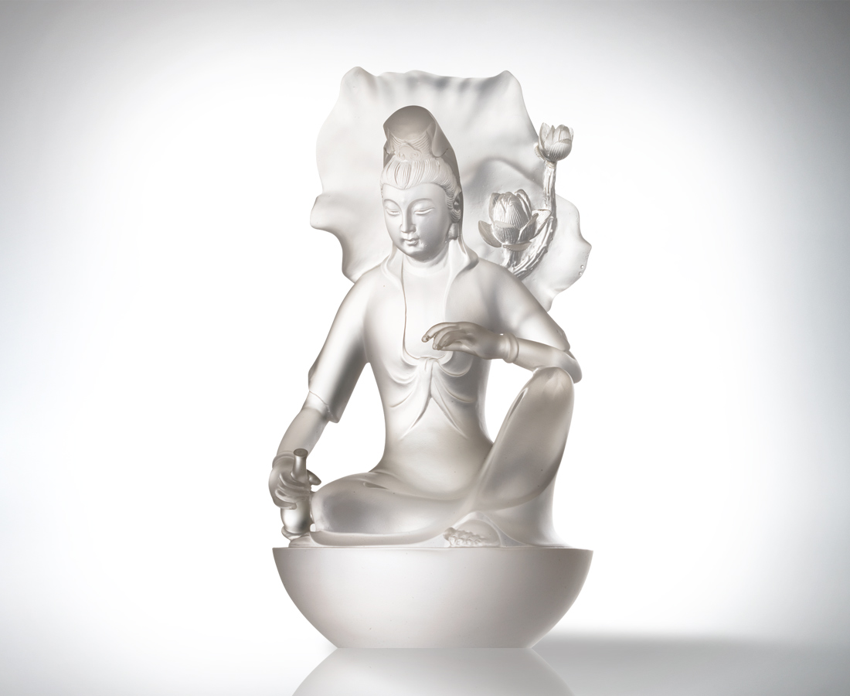
遍灑清淨 娑婆芬芳
無欲而剛 光明淨土
Radiance
Illuminating the vast lands, Emanating elegance and delicate beauty Renouncing worldly desires with an inner strength, Radiating brilliance

編號 | 1212247 | No | 1212247
名稱 | 光明淨土 | Name | Radiance
顏色 | 透(噴砂) | Color | sand blasted lucid
尺寸 | 15.5 * 15.5 * 29.2 | Size | 15.5 * 15.5 * 29.2
重量 | 4.7 | Weight | 4.7
限量 | O | Limited Edition | O
售價 | NT$ 39600 | Price | NT$ 39600
 | RMB$ 9188 |  | RMB$ 9188

