大願力 | 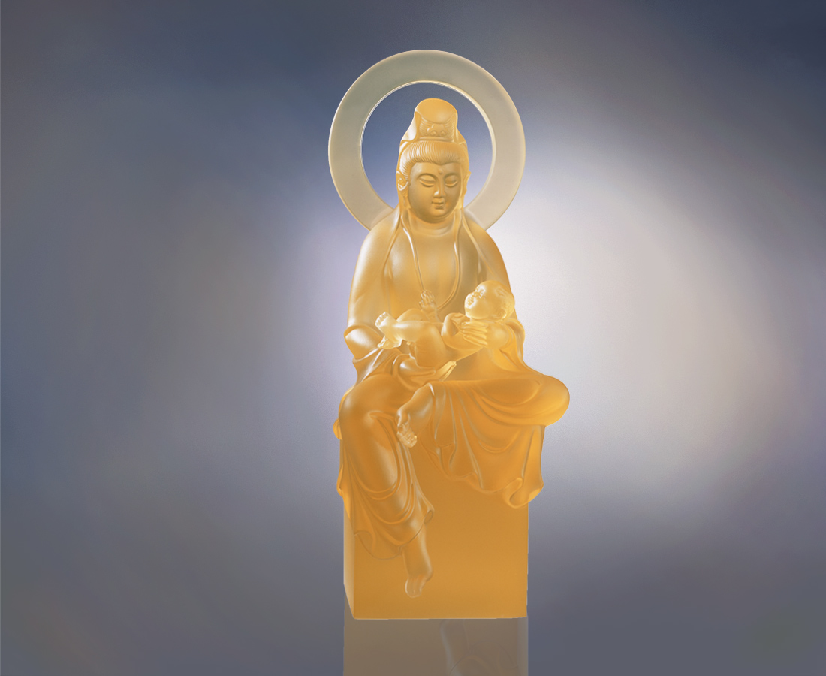
緣生緣滅 四大皆空
佛光普照 善斷能絕
當下大願 冉升希望
喜捨得樂 福慧雙至
The Power of Hope
Life and death are pre-destined, nothing is permanent Buddha’s shining light is omnipresent, bringing good to one and all Creating boundless optimism and continuous hope Charity and caring begets happiness, generating fortune and wisdom

編號 | 1212046 | No | 1212046
名稱 | 大願力 | Name | The Power of Hope
顏色 | 琥／金(噴砂) | Color | amber／golden (sand blasting)
尺寸 | 11.5 * 12.5 * 30.7 | Size | 11.5 * 12.5 * 30.7
重量 | 3.5 | Weight | 3.5
限量 | O | Limited Edition | O
售價 | NT$ 36800 | Price | NT$ 36800
 | RMB$ 9188 |  | RMB$ 9188

