活佛 | 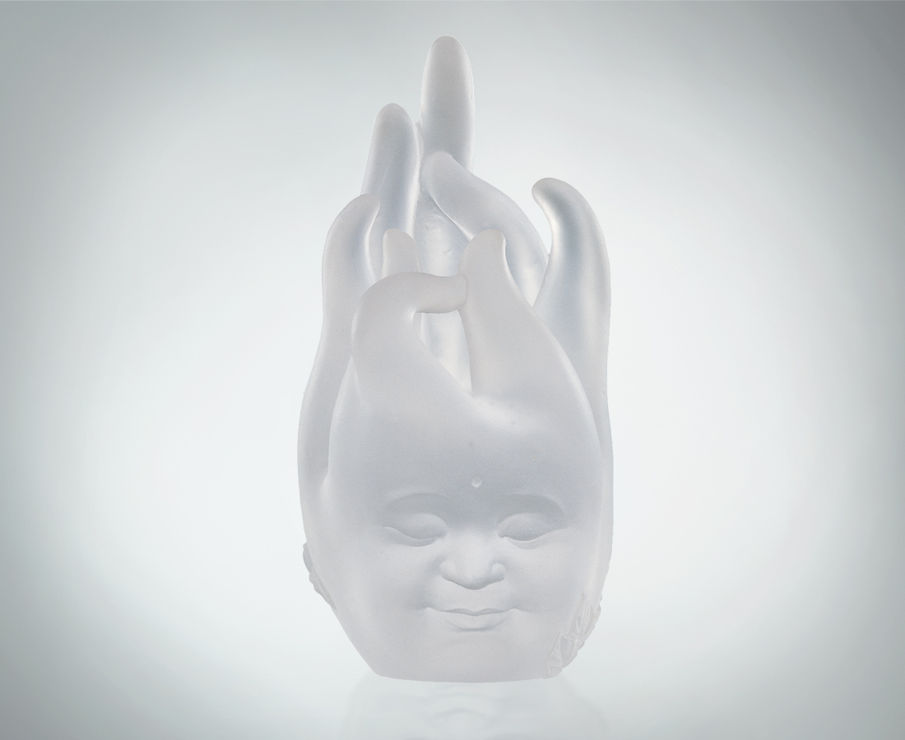
生命要起舞
在空間中茁壯
學習和諧 了然空無
生長要歷練
在自然中成熟
探索自在 順乎天真
每種色相有因果
每樣肢體是邏輯
娑婆世界 皆說諸法
佛手佛首 大慈大悲
一草一木 都是活佛
Natural Buddha
Life must begin dancing, Vigorously sprouting amidst Emptiness; Learning harmony, understanding true Emptiness. Long life must undergo training, Ripening in the midst of Nature; Exploring freely, following true Innocence. All phenomena are interconnected. Every type of body has its logic. Buddha hand, Buddha head The whirling, dancing world. Hands down the teaching of Great Compassion. Each blade of grass, each tree. All speak of the Great Law.

編號 | 1208089 | No | 1208089
名稱 | 活佛 | Name | Natural Buddha
顏色 | 透 | Color | clear
尺寸 | 8 * 7 * 14 | Size | 8 * 7 * 14
重量 | 0.95 | Weight | 0.95
限量 | O | Limited Edition | O
售價 | NT$ 5260 | Price | NT$ 5260
 | RMB$ 1388 |  | RMB$ 1388

