拂曉 | 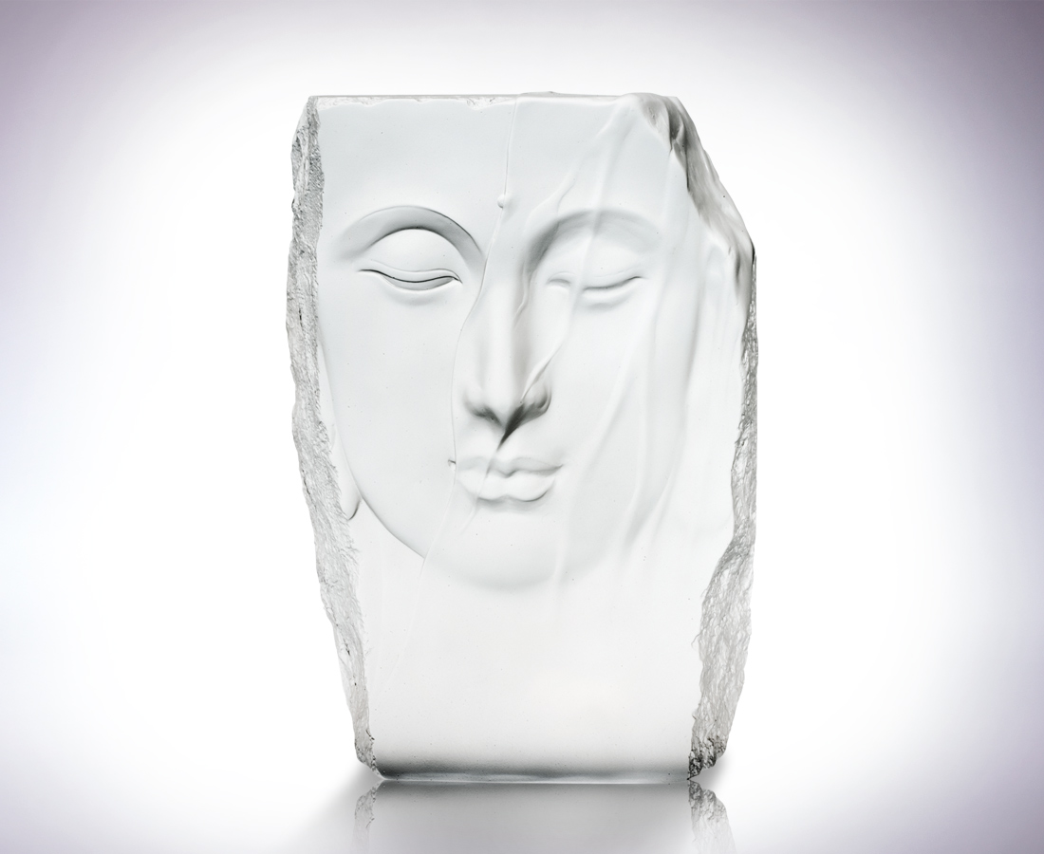
黑夜最後的薄紗 矜持
白晝初啟的慈悲 甦醒
或來風掀開
或來雨滌清
或來日普照
光華本我 菩提現身
Dawning
The last veils of the night Reserve The first mercies of the day Awake Perhaps ruffled by the wind Perhaps cleansed by the rain Perhaps illuminated by the sun I am the light the Goddess revealed

編號 | 1202437 | No | 1202437
名稱 | 拂曉 | Name | Dawning
顏色 | 透(噴砂) | Color | sand blasted lucid
尺寸 | 7.4 * 16 * 22.4 | Size | 7.4 * 16 * 22.4
重量 | 5.15 | Weight | 5.15
限量 | O | Limited Edition | O
售價 | NT$ 22680 | Price | NT$ 22680
 | RMB$ 4888 |  | RMB$ 4888

