捻花持悲 | 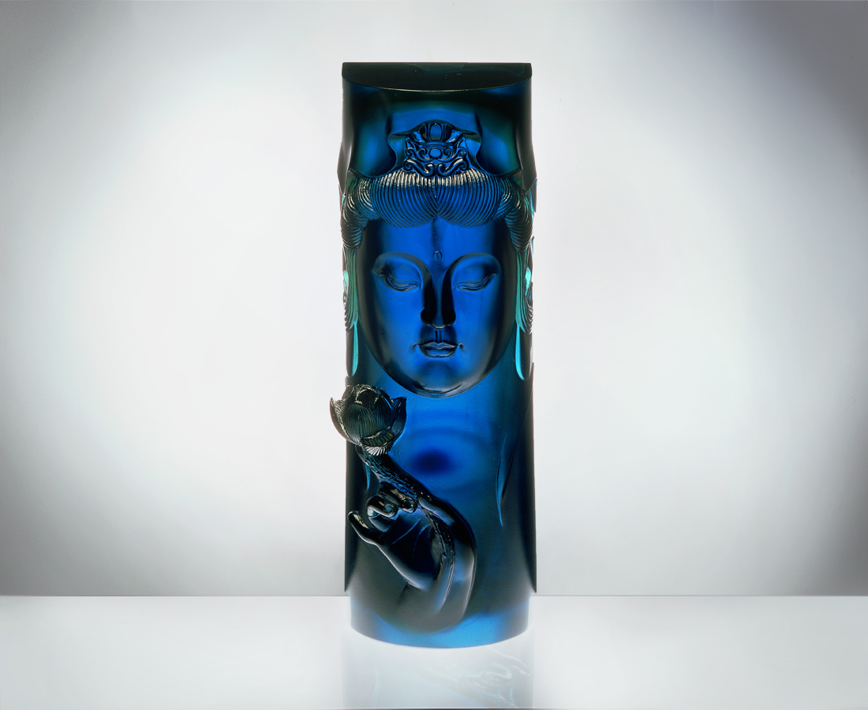
捻花 於萬物捻起智慧
持悲 於萬象昇起慈悲
Hold The Lotus, Embrace Compassion(Bodisattva Hold
Hold the lotus, provoke wisdom in all existence Embrace compassion, raise compassion in all beings

編號 | 1201061 | No | 1201061
名稱 | 捻花持悲 | Name | Hold The Lotus, Embrace Compassion(Bodisattva Hold
顏色 | 透／青／金 | Color | clear / cyan / golden
尺寸 | 9 * 9.1 * 23.5 | Size | 9 * 9.1 * 23.5
重量 | 3.7 | Weight | 3.7
限量 | O | Limited Edition | O
售價 | NT$ 20100 | Price | NT$ 20100
 | RMB$ 5050 |  | RMB$ 5050

