安婕妤 | 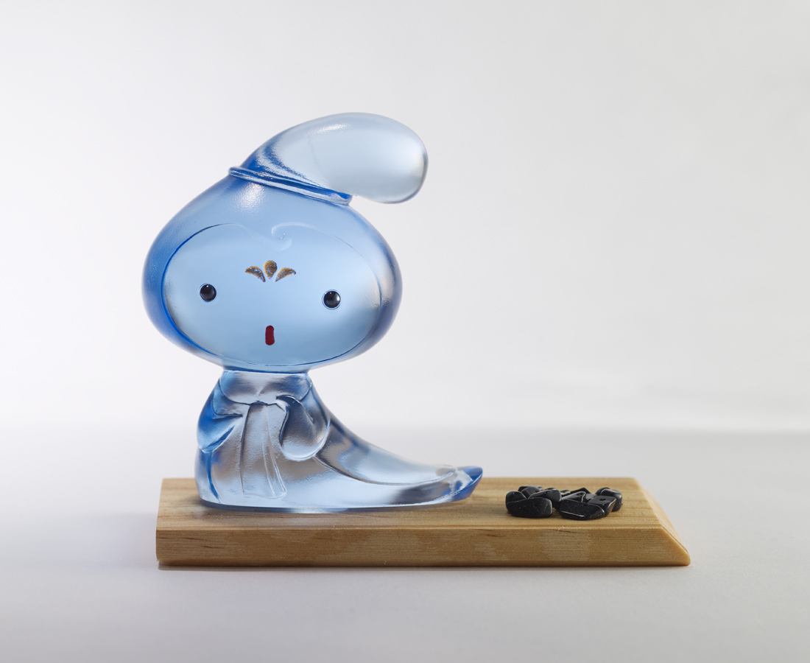
側髮 瞇眼
彎著腰
避凶 見吉
好平安
Chinese style big head doll (blue)
Tittot designed this cute big head doll based on the female hairstyles in Tang Dynasty. The designer used the figure of a bowed body to create a symbol that stands for avoiding the upcoming bad luck and embracing a happy future.

編號 | 1173749 | No | 1173749
名稱 | 安婕妤 | Name | Chinese style big head doll (blue)
顏色 | 藍 | Color | blue
尺寸 | 8.5 * 5.1 * 9.5 | Size | 8.5 * 5.1 * 9.5
重量 | 0.39 | Weight | 0.39
限量 | X | Limited Edition | X
售價 | NT$ 2880 | Price | NT$ 2880
 | RMB$ 640 |  | RMB$ 640

