武才人 | 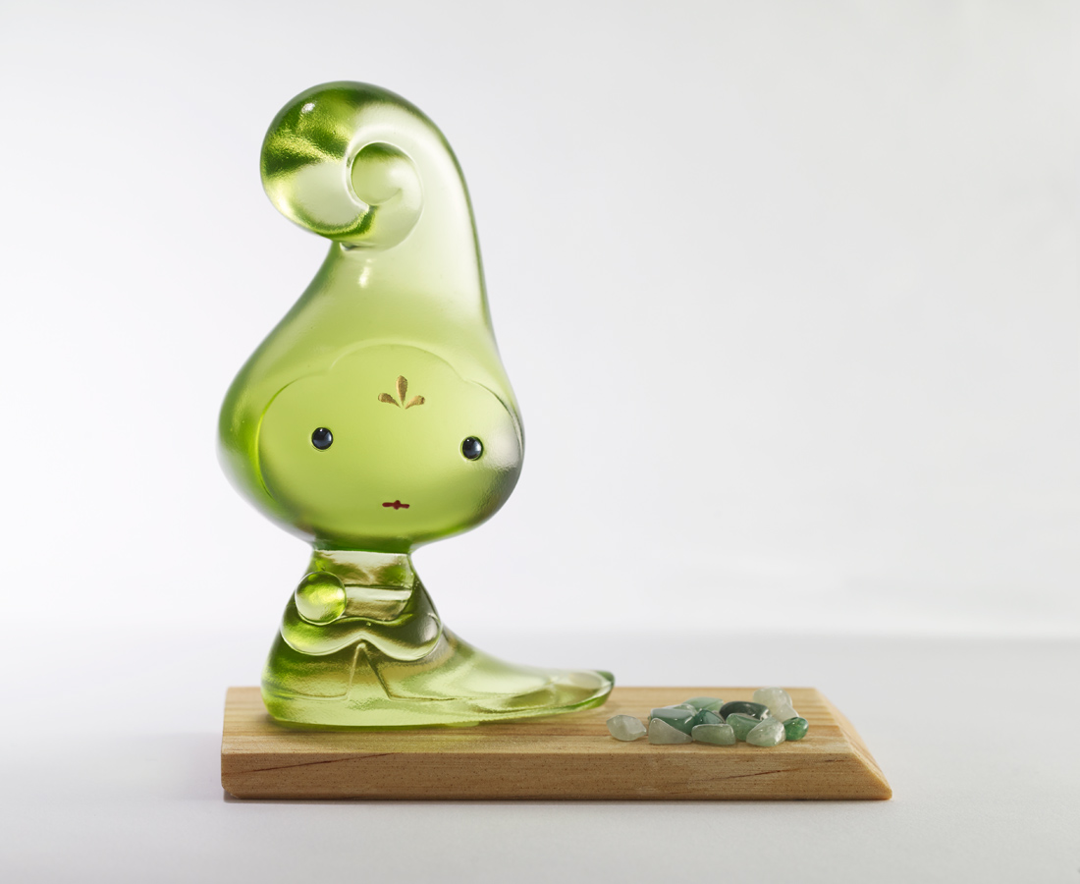
我們的志氣比天高
髮型能高人一等
離成功更進一步
Chinese style big head doll (green)
Tittot designed this cute big head doll based on the female hairstyles in Tang Dynasty.The pull-up and tall hairdo is like a woman with her own strong opinions, demonstrating the beauty of confidence on her life and career.

編號 | 1173748 | No | 1173748
名稱 | 武才人 | Name | Chinese style big head doll (green)
顏色 | 綠 | Color | green
尺寸 | 8.7 * 5.1 * 12 | Size | 8.7 * 5.1 * 12
重量 | 0.39 | Weight | 0.39
限量 | X | Limited Edition | X
售價 | NT$ 2880 | Price | NT$ 2880
 | RMB$ 640 |  | RMB$ 640

