情貴妃 | 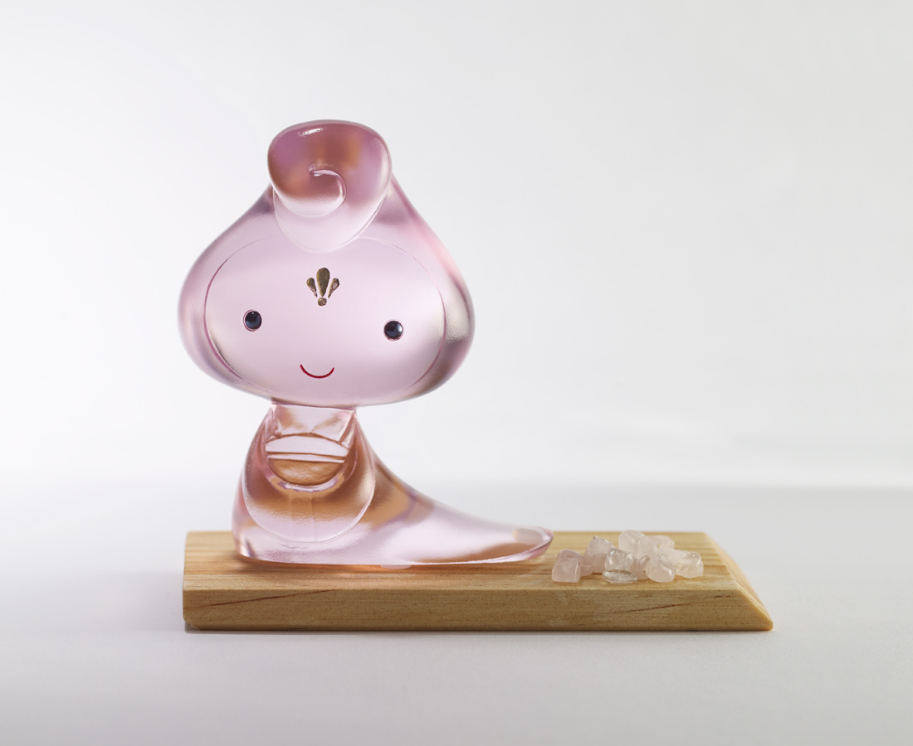
只要有愛
你我怎樣都好
人生有情
天地如何都美
Chinese style big head doll (pink)
Tittot designed this cute big head doll based on the female hairstyles in Tang Dynasty. Pink color symbolizes love. The expression on the doll’s face shows the smile while feeling the beautiful love.

編號 | 1173747 | No | 1173747
名稱 | 情貴妃 | Name | Chinese style big head doll (pink)
顏色 | 粉 | Color | pink
尺寸 | 9.1 * 5.1 * 9.6 | Size | 9.1 * 5.1 * 9.6
重量 | 0.39 | Weight | 0.39
限量 | X | Limited Edition | X
售價 | NT$ 2880 | Price | NT$ 2880
 | RMB$ 640 |  | RMB$ 640

