金昭儀 | 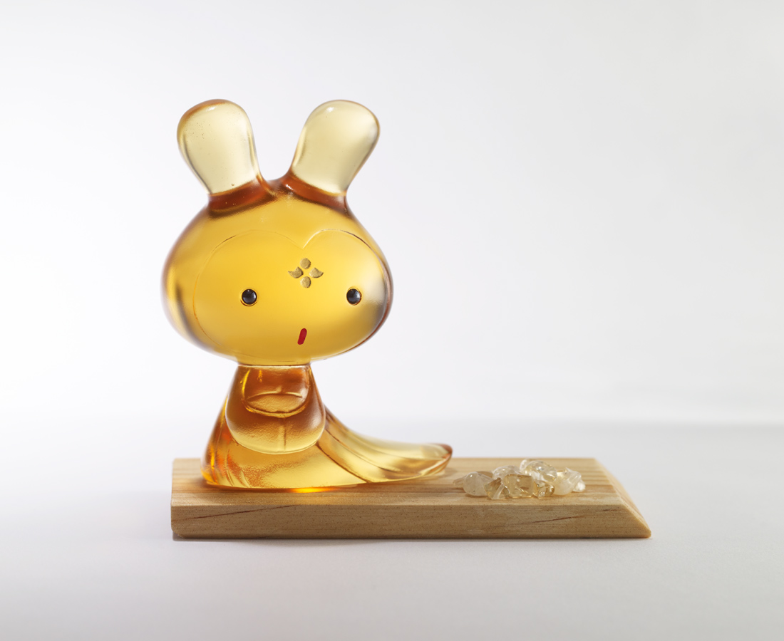
嘟著小嘴拜託你
跟我一起
把財寶搬回家吧
Chinese style big head doll (golden)
Tittot designed this cute big head doll based on the female hairstyles in Tang Dynasty. Gold color symbolizes fortune in Chinese culture, which can be a symbol of bringing wealth to one’s life.

編號 | 1173746 | No | 1173746
名稱 | 金昭儀 | Name | Chinese style big head doll (golden)
顏色 | 金 | Color | golden
尺寸 | 8.5 * 5.3 * 10.3 | Size | 8.5 * 5.3 * 10.3
重量 | 0.39 | Weight | 0.39
限量 | X | Limited Edition | X
售價 | NT$ 2880 | Price | NT$ 2880
 | RMB$ 640 |  | RMB$ 640

