添才 | 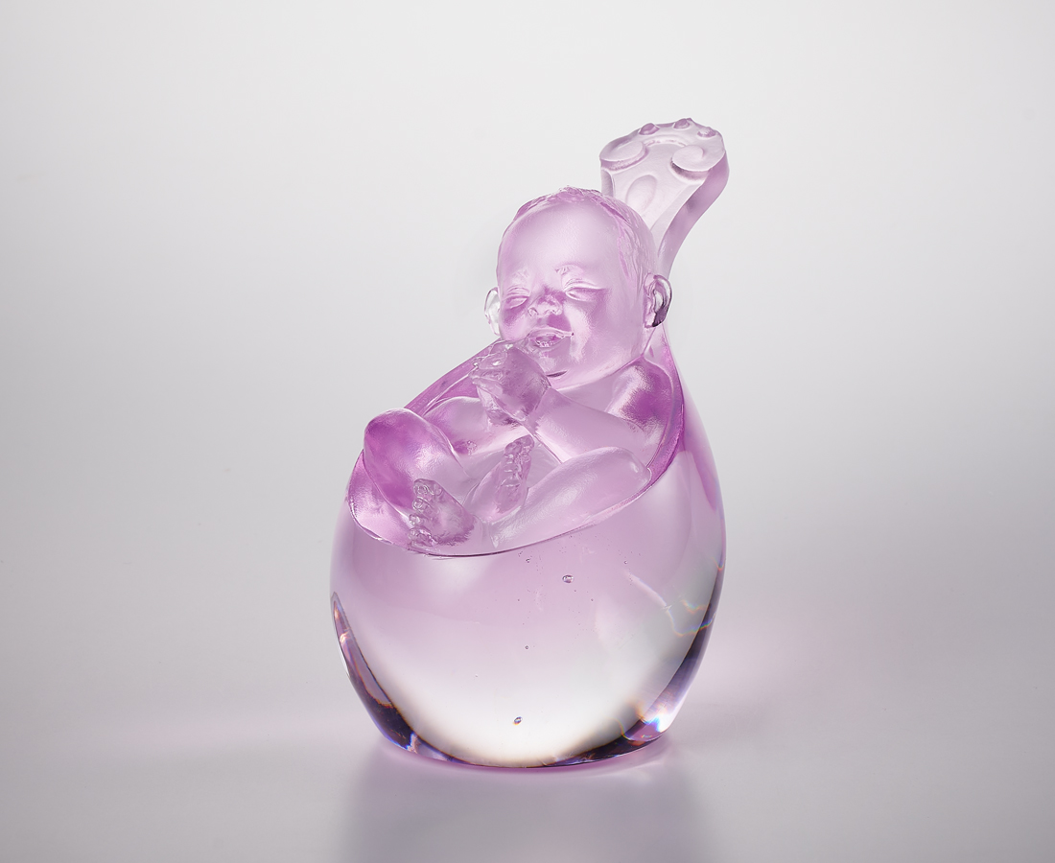
在歡笑中恩典降臨
在期待中綻放希望
一雙小小的手 緊握人間
一對肉肉的足 邁向未來
從此 世界添了份禮物
因為你就是
The Blessings of Birth
In Chinese folklore, there is a saying "born with a golden spoon in one's mouth", which means that a child has come into this world full of blessings. Inspired by this proverb, this work is sculpted and cast exquisitely to express the utmost joy for the beautiful new birth.

編號 | 1164121 | No | 1164121
名稱 | 添才 | Name | The Blessings of Birth
顏色 | 粉紅透 | Color | pink, clear
尺寸 | 8.7 * 5.8 * 8 | Size | 8.7 * 5.8 * 8
重量 | 0.35 | Weight | 0.35
限量 | X | Limited Edition | X
售價 | NT$ 5200 | Price | NT$ 5200
 | RMB$ 1180 |  | RMB$ 1180

