慈揹 | 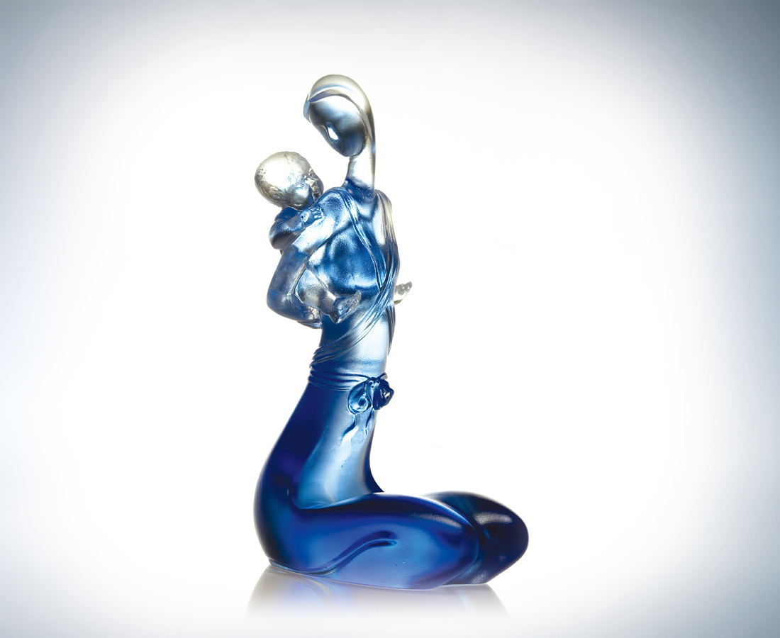
你的無盡付出
揹起我歡笑的世界
你的層層呵護
構築我一生的自信
緊記堅強無私的背影
回味得天獨厚的慈愛
共鳴身心相繫的脈動
The Loving Back
Your selfless devotion Brings laughter and joy to my world Your loving care and guidance Gives me confidence I will always remember your strength and selflessness And value the boundless love That will be the pillars of my moral being

編號 | 1162261 | No | 1162261
名稱 | 慈揹 | Name | The Loving Back
顏色 | 藍透／金琥 | Color | lucid blue／golden amber
尺寸 | 9 * 6.8 * 15.9 | Size | 9 * 6.8 * 15.9
重量 | 0.69 | Weight | 0.69
限量 | X | Limited Edition | X
售價 | NT$ 6780 | Price | NT$ 6780
 | RMB$ 1688 |  | RMB$ 1688

