富貴緣 | 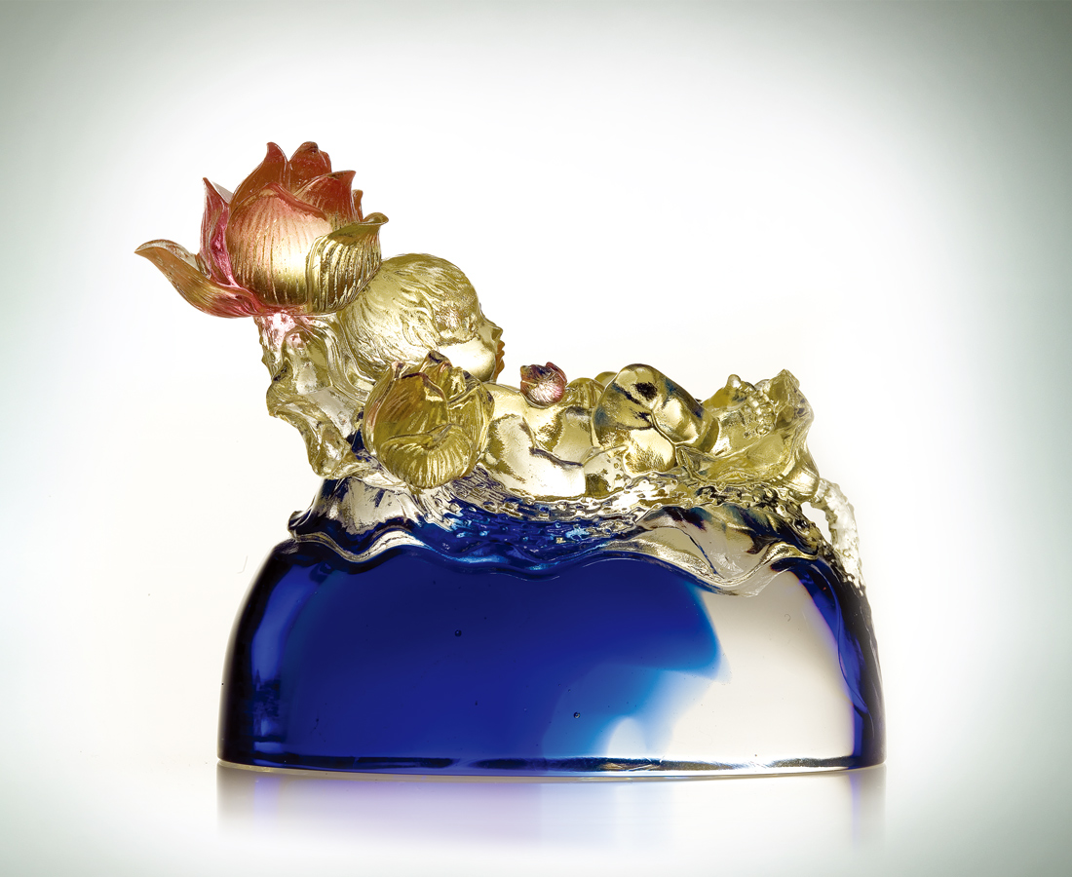
一心安然自足
一身悠然自得
一派泰然自若
祝福一生隨心所欲
吹送一世富貴圓滿
隨喜天成 慶賀天賜因緣
怡然徜徉生命自在的和諧
Blessings of fortune
Serene and contented Carefree and self-assured Always with poise and confidence Blessed with a life of fulfilled wishes Welcoming with open arms a life of good fortune Celebrating the happiness and blessings of heaven Relishing the harmony and freedom of life

編號 | 1162173 | No | 1162173
名稱 | 富貴緣 | Name | Blessings of fortune
顏色 | 金藍透紅／琥紫綠透 | Color | golden, blue, red, clear／ amber, purple, green, clear
尺寸 | 4.4 * 10.6 * 8.4 | Size | 4.4 * 10.6 * 8.4
重量 | 0.47 | Weight | 0.47
限量 | X | Limited Edition | X
售價 | NT$ 3980 | Price | NT$ 3980
 | RMB$ 996 |  | RMB$ 996

