好平安 | 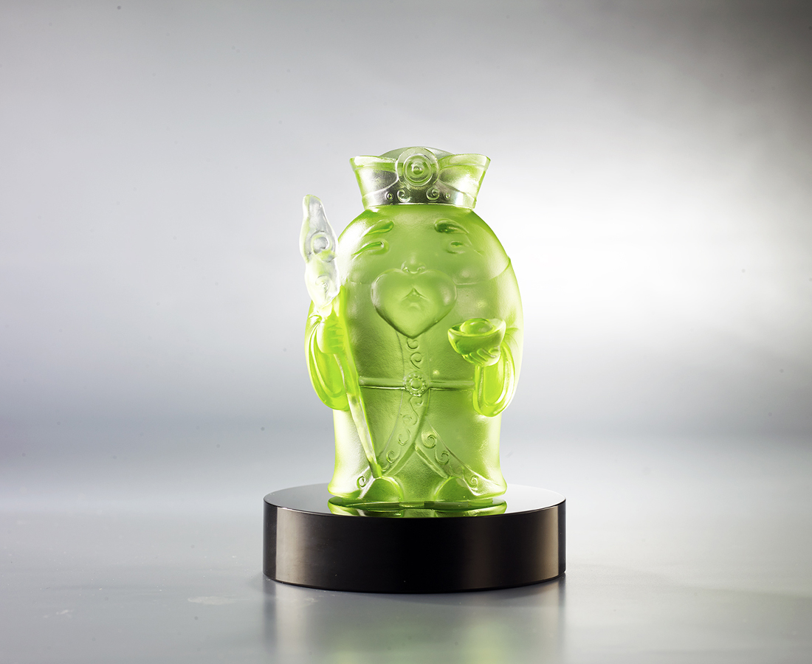
有土斯有財
有家才平安
有好心 運就開
有笑容 就平安
The Land God
The idea of the Land God originated in the farmers’ worship of the earth and their prayers for a good harvest, and gradually evolved into a patron deity who could protect the whole family and bring security and wealth. This piece of work shows the Land God as a kindly grandfather figure who cares for the happiness of the whole family.

編號 | 1153827 | No | 1153827
名稱 | 好平安 | Name | The Land God
顏色 | 草綠 + 黑色底座 | Color | grass-green + black base
尺寸 | 5.8 * 5.6 * 9.1 | Size | 5.8 * 5.6 * 9.1
重量 | 0.42 | Weight | 0.42
限量 | O | Limited Edition | O
售價 | NT$ 4680 | Price | NT$ 4680
 | RMB$ 960 |  | RMB$ 960

