好聰明 | 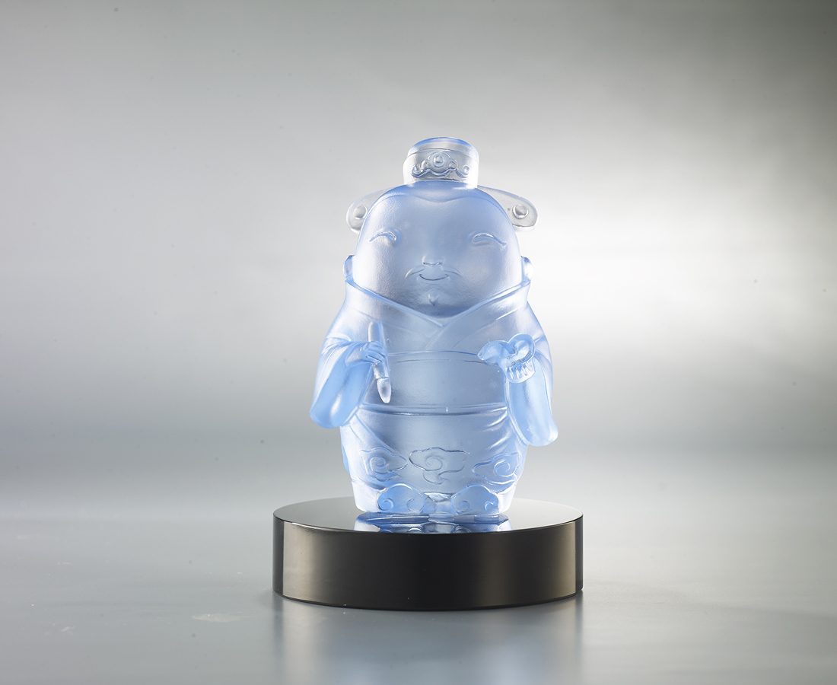
十年寒窗
織成滿腹文章
恰到好處
點出錦繡人生
成功是天時地利
更是盡其所能
聰明人善用時機
成功 事半功倍
The Wenchang Emperor
The Wenchang Emperor is the god in charge of literature. The pen in his hand can decide the attainments of scholars throughout their lives, as well as their wisdom and ability. For this reason, many students worship him in the hope of getting good grades in examinations.

編號 | 1153826 | No | 1153826
名稱 | 好聰明 | Name | The Wenchang Emperor
顏色 | 淺藍 + 黑色底座 | Color | blue + black base
尺寸 | 6.3 * 5.4 * 9.4 | Size | 6.3 * 5.4 * 9.4
重量 | 0.4 | Weight | 0.4
限量 | O | Limited Edition | O
售價 | NT$ 4680 | Price | NT$ 4680
 | RMB$ 960 |  | RMB$ 960

