好良緣 | 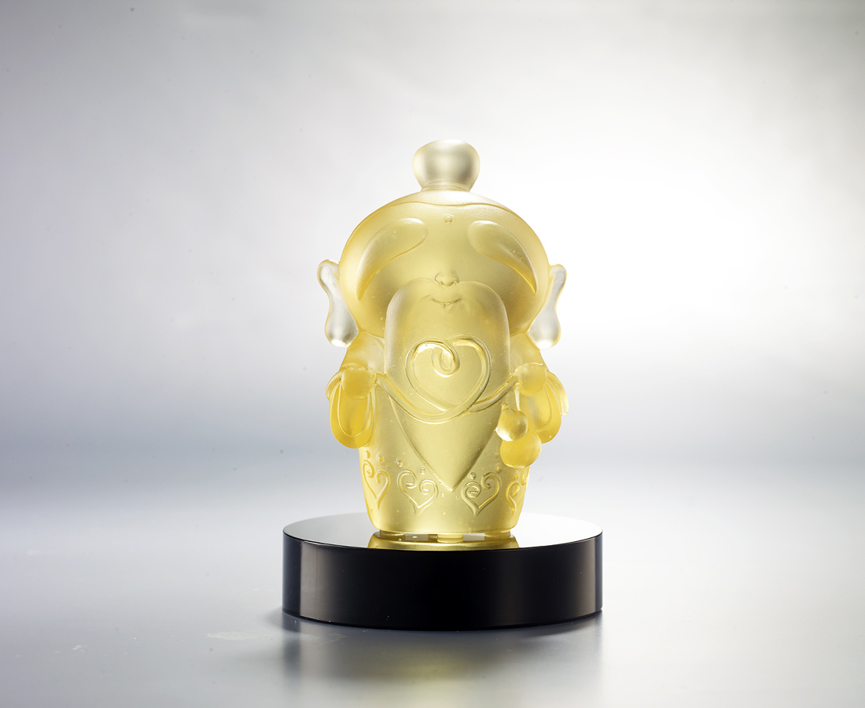
福祿 姻緣
都是天註定
諒解 珍惜
都是處世方
同船渡 共枕眠
心手相和 牽成好緣
The Old Man in the Moonlight – The Chinese Cupid
According to myth, the old man is the god in charge of marriage. He ties each pair of lovers together using a piece of red cord. In this work, the old man shapes the red cord into a heart symbol, denoting lasting affection between lovers.

編號 | 1153825 | No | 1153825
名稱 | 好良緣 | Name | The Old Man in the Moonlight – The Chinese Cupid
顏色 | 金 + 黑色底座 | Color | Gold + black base
尺寸 | 6.4 * 5 * 9.6 | Size | 6.4 * 5 * 9.6
重量 | 0.36 | Weight | 0.36
限量 | O | Limited Edition | O
售價 | NT$ 4680 | Price | NT$ 4680
 | RMB$ 960 |  | RMB$ 960

