好寶貝 | 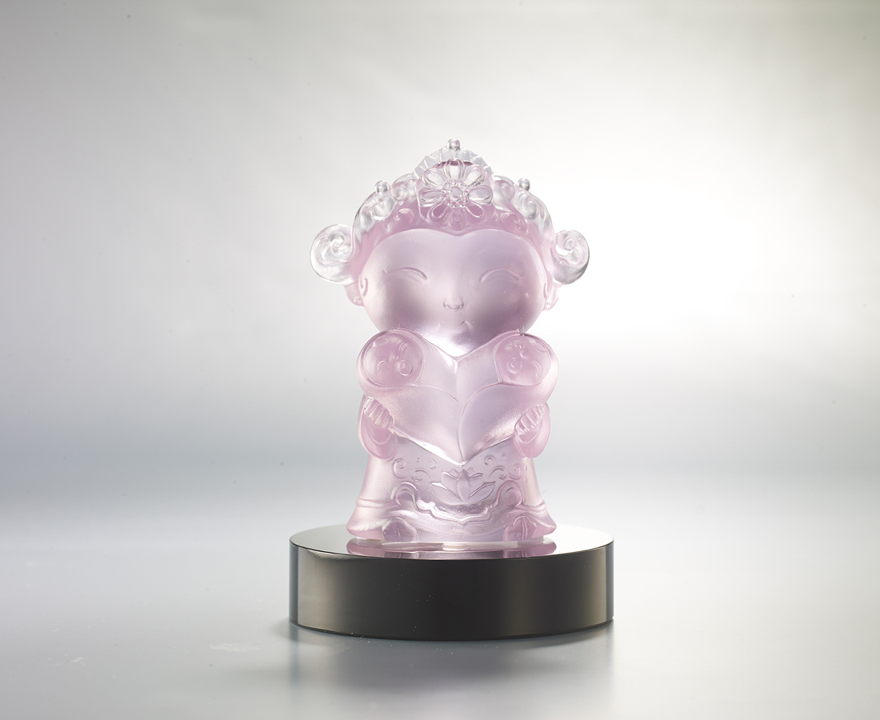
註生 祝生 助生
一個不嫌少
兩個恰恰好
祝福生命的孕育
祝福生命的美好
The Goddess of Childbirth
Tradition has it that this goddess can protect women during childbirth. This piece depicts a mother holding two babies, symbolizing the difficulties and joys involved in raising children, and extending a blessing to all mothers that they may be healthy and happy.

編號 | 1153824 | No | 1153824
名稱 | 好寶貝 | Name | The Goddess of Childbirth
顏色 | 粉紅 + 黑色底座 | Color | pink + black base
尺寸 | 6.9 * 5 * 9.8 | Size | 6.9 * 5 * 9.8
重量 | 0.34 | Weight | 0.34
限量 | O | Limited Edition | O
售價 | NT$ 4680 | Price | NT$ 4680
 | RMB$ 960 |  | RMB$ 960

