好有錢 | 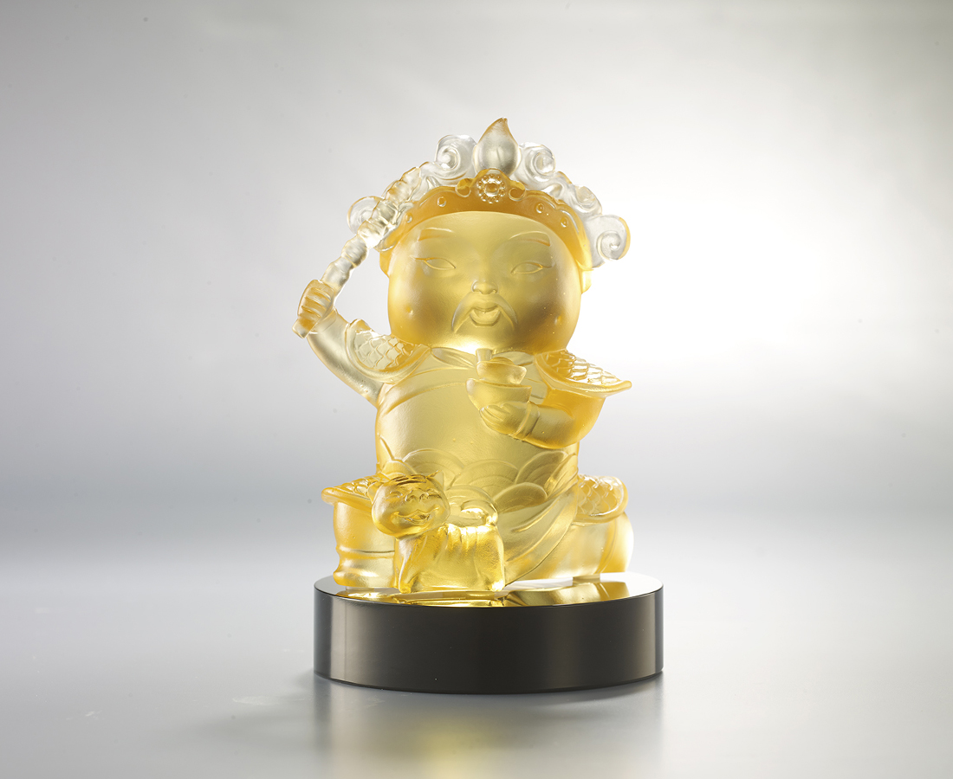
腳踏實地 生財有道
昂首闊步 如虎添翼
哪怕白手起家
也能飛黃騰達
Zhao Gongming
According to legend, the Shang Dynasty immortal, Zhao Gongming, gave or took away riches from people on the basis of their good or bad conduct. So many people worship him and pray that he will increase their wealth.

編號 | 1153823 | No | 1153823
名稱 | 好有錢 | Name | Zhao Gongming
顏色 | 淺琥 + 黑色底座 | Color | amber + black base
尺寸 | 8.6 * 5 * 10.5 | Size | 8.6 * 5 * 10.5
重量 | 0.41 | Weight | 0.41
限量 | O | Limited Edition | O
售價 | NT$ 4680 | Price | NT$ 4680
 | RMB$ 960 |  | RMB$ 960

