隆運 | 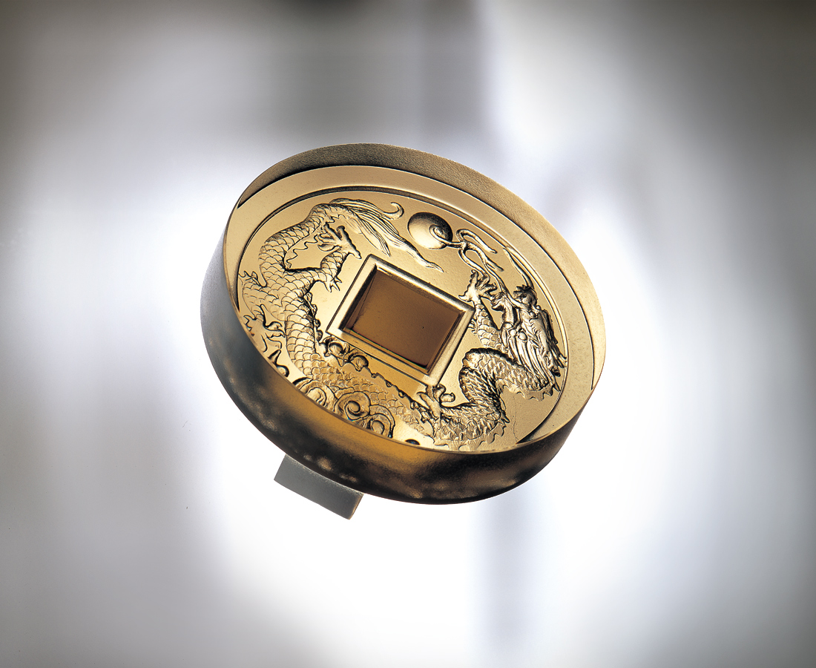
包圍心思 滴水不漏
裡裡外外 圈圈端詳
出擊決心 根深蒂固
上上下下 層層深植
養精蓄銳 無攻不破
雄心大志 翱翔四方
天地循環 生生不息
滾滾隆運 不停常轉
Prosperity
Surround your heart’s thoughts—so not a drop will leak; Inside and outside—looking around and around; Thrust forth determination—solidly rooted.; Up and down—deeply planted layer after layer; Nourish one’s strength—Every blow hits its mark; Harboring great ambition—Soaring to the ends of the earth; The cycles of heaven and earth—Endless renewal; Surging prosperity—Ceaselessly rolling.

編號 | 1149120 | No | 1149120
名稱 | 隆運 | Name | Prosperity
顏色 | 茶 | Color | brown
尺寸 | 7.9 * 7.9 * 6.4 | Size | 7.9 * 7.9 * 6.4
重量 | 0.42 | Weight | 0.42
限量 | O | Limited Edition | O
售價 | NT$ 2860 | Price | NT$ 2860
 | RMB$ 788 |  | RMB$ 788

