鳳迴龍轉一世情 | 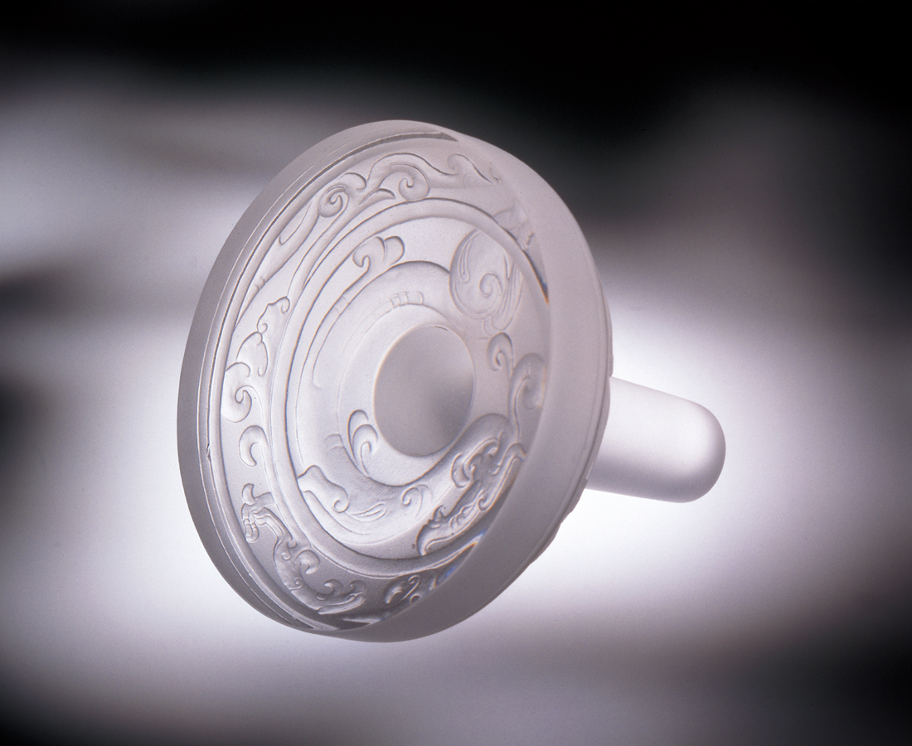
峰迴路轉一世情
不同方向的輪轉
總有相對的一刻
良緣是前世註定
相守是今生誓言
大世界你我同心
小天地濃情常圓
圓圓圈圈最真情
A Life of Affection Amidst Twisting Phoenixes and Whirling Dragons
A life of affection amidst twisting roads and jagged peaks, Rotating in different directions. The right time will eventually come, Good affinities are predestined from an earlier time. Mutually upholding this life’s vows: In this great world you and I share the same heart. In this little sphere strong feelings form a constant circle, A round circle of the truest emotion.

編號 | 1149079 | No | 1149079
名稱 | 鳳迴龍轉一世情 | Name | A Life of Affection Amidst Twisting Phoenixes and Whirling Dragons
顏色 | 透 | Color | clear
尺寸 | 6 * 8 * 8 | Size | 6 * 8 * 8
重量 | 0.45 | Weight | 0.45
限量 | O | Limited Edition | O
售價 | NT$ 3380 | Price | NT$ 3380
 | RMB$ 688 |  | RMB$ 688

