攏發財 | 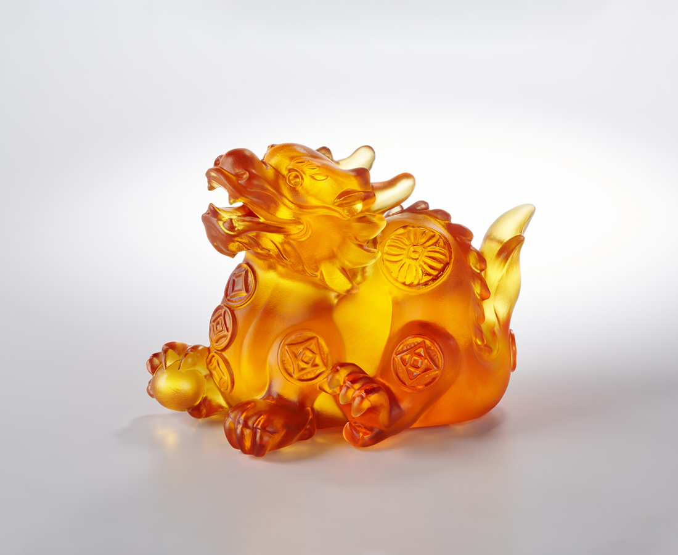
抬了龍頭 開了笑口
自信自由 自是風調雨順好兆頭
一去漫天飛 二來尤自在
財寶家己來
逐家攏發財
Fortune Chinese Dragon
The Chinese dragon is the most representative animal in Chinese culture, symbolizing good fortune and power, as well as a sacred symbol of ancient imperial power. In the work, the dragon is adorned with the traditional Chinese coin totem, which carries the symbolic meaning of praying for good fortune and attracting wealth while adding spices to daily life.

編號 | 1144105 | No | 1144105
名稱 | 攏發財 | Name | Fortune Chinese Dragon
顏色 | 琥 | Color | amber
尺寸 | 10.7 * 6.2 * 7.9 | Size | 10.7 * 6.2 * 7.9
重量 | 0.51 | Weight | 0.51
限量 | O | Limited Edition | O
售價 | NT$ 4480 | Price | NT$ 4480
 | RMB$ 1000 |  | RMB$ 1000

