麟生圓滿 | 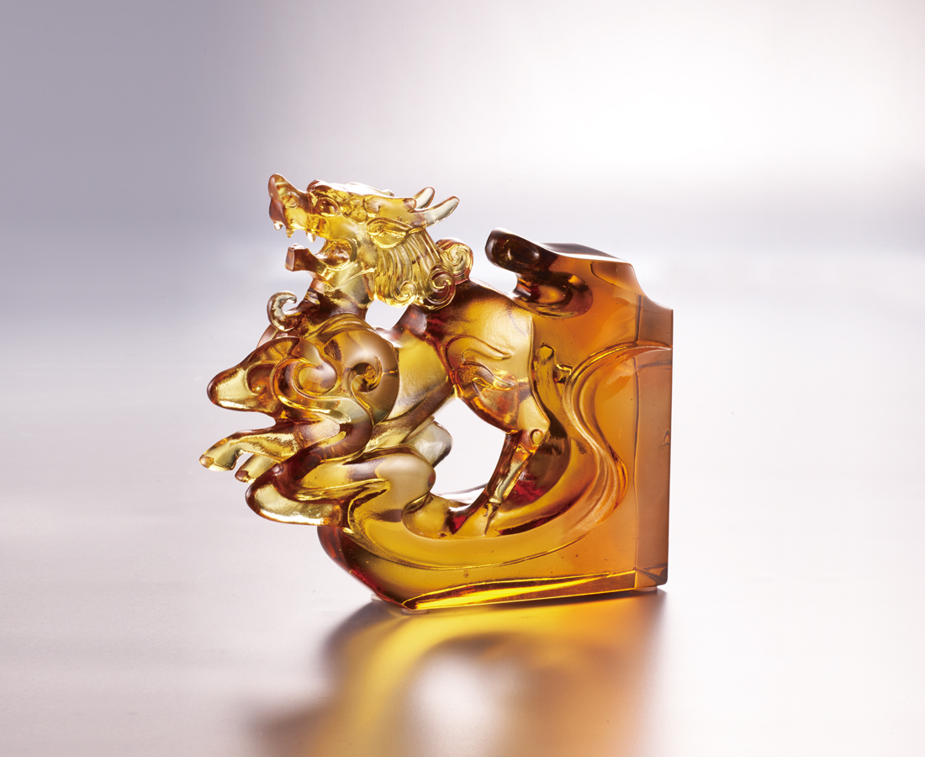
心中存信念
踏遍寰宇 一生坦然
道義一肩擔
古往今來 成就四方
於我 瀟灑自在
於人 隨意圓滿
Queti - Qilin
The philosophy of Wuxing, or the Five Elements can be derived into other combinations, such as the Five Virtue (Benevolence, righteousness, courteousness, wisdom, and sincerity) and the Five Creatures (Dragon, Phoenix, Tiger, Tortoise, and Qilin). Qilin symbolizes sincerity and trust. Tittot makes use of its exquisite skills of crystal glass to represent the uniqueness of Chinese culture.

編號 | 1143871 | No | 1143871
名稱 | 麟生圓滿 | Name | Queti - Qilin
顏色 | 深琥茶透 | Color | dark amber, brown, clear
尺寸 | 12.2 * 3.3 * 10.5 | Size | 12.2 * 3.3 * 10.5
重量 | 0.54 | Weight | 0.54
限量 | O | Limited Edition | O
售價 | NT$ 5280 | Price | NT$ 5280
 | RMB$ 1180 |  | RMB$ 1180

