玄武納福 | 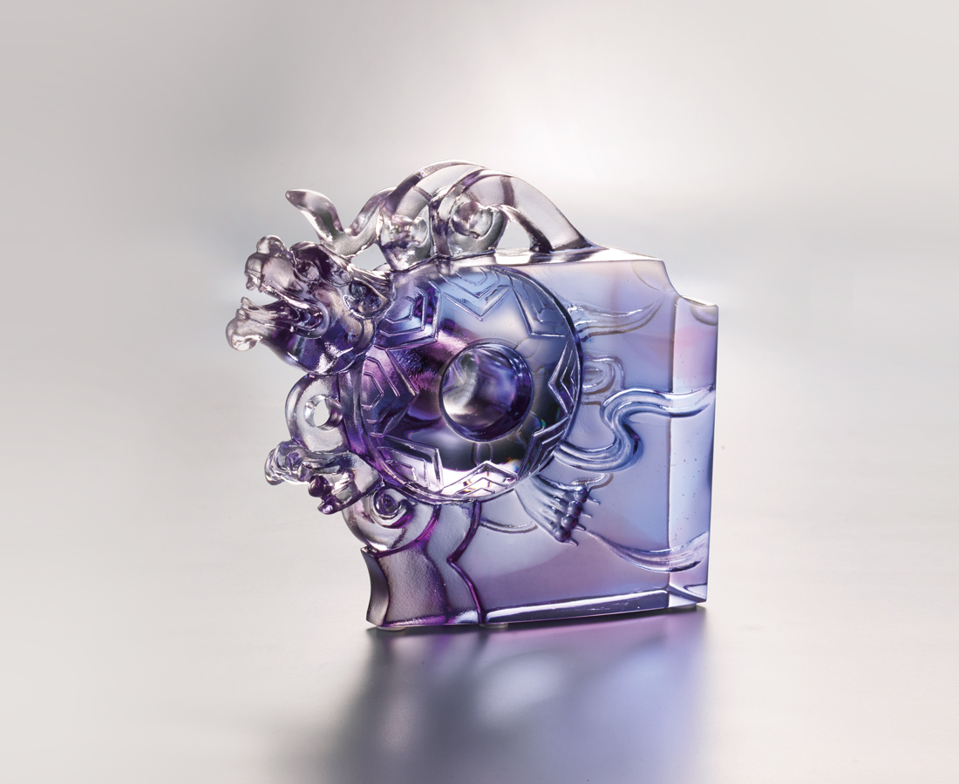
循天圓 蹈地方
風生水起 有始有終
春往秋來心不亂
隨他東西南北風
我自瀟灑我自得
觀自在 納福祥
也無風雨也無晴
Queti – Tortoise
The Xuan-Wu, aka black tortoise is one of the Five Elements in Chinese culture, symbolizing the north, winter, and steadiness. This creature can also be derived into other combinations, such as the Five Virtue (Benevolence, righteousness, courteousness, wisdom, and sincerity) and the Five Creatures (Dragon, Phoenix, Tiger, Tortoise, and Qilin). Using large pieces of crystal glass, ttittot aims to deliver the tortoise’s calmness, a force to the next success.

編號 | 1143870 | No | 1143870
名稱 | 玄武納福 | Name | Queti – Tortoise
顏色 | 藍灰透 | Color
尺寸 | 11.6 * 4 * 10.6 | Size | 11.6 * 4 * 10.6
重量 | 0.64 | Weight | 0.64
限量 | O | Limited Edition | O
售價 | NT$ 5280 | Price | NT$ 5280
 | RMB$ 1180 |  | RMB$ 1180

