鳳迎富貴 | 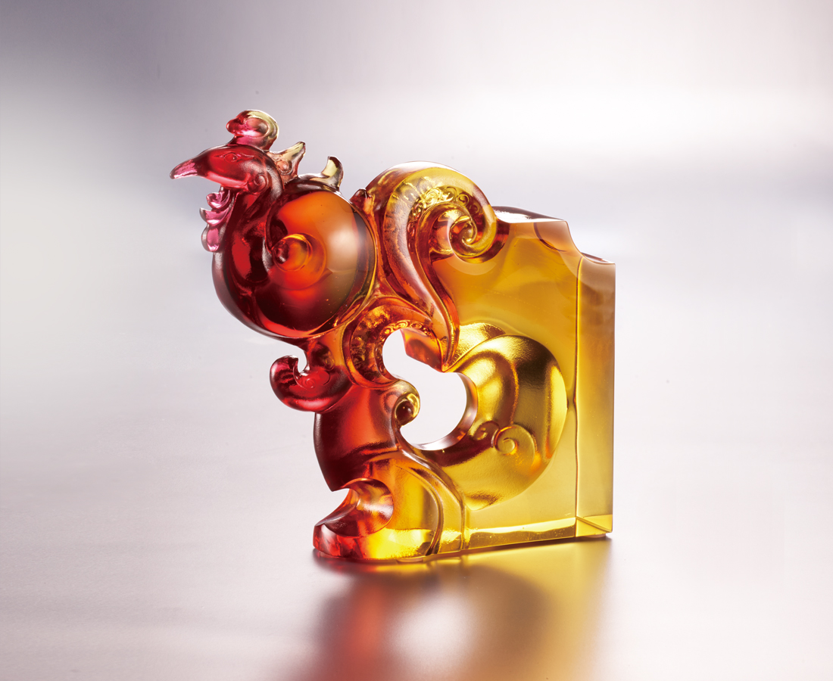
抖擻 迎日趕月
一身紅火光華
情感奔騰 熱烈澎湃
熱情隨風 日日飛舞
乘風而起 隨光展翅
款款幽雅 迎向富貴
Queti - Phoenix
South, a term full of enthusiasm and charisma, is represented by Phoenix in Chinese culture. The gorgeous colors of its feathers, the breathtaking agility of its posture, connects to our feels to the Southern warmth. The Phoenix designed by tittot conveys enthusiasm and dream, bringing splendid phases to our lives.

編號 | 1143869 | No | 1143869
名稱 | 鳳迎富貴 | Name | Queti - Phoenix
顏色 | 紅琥透 | Color | red, amber, clear
尺寸 | 11.7 * 3.3 * 11.2 | Size | 11.7 * 3.3 * 11.2
重量 | 0.45 | Weight | 0.45
限量 | O | Limited Edition | O
售價 | NT$ 5280 | Price | NT$ 5280
 | RMB$ 1180 |  | RMB$ 1180

