虎勢高昇 | 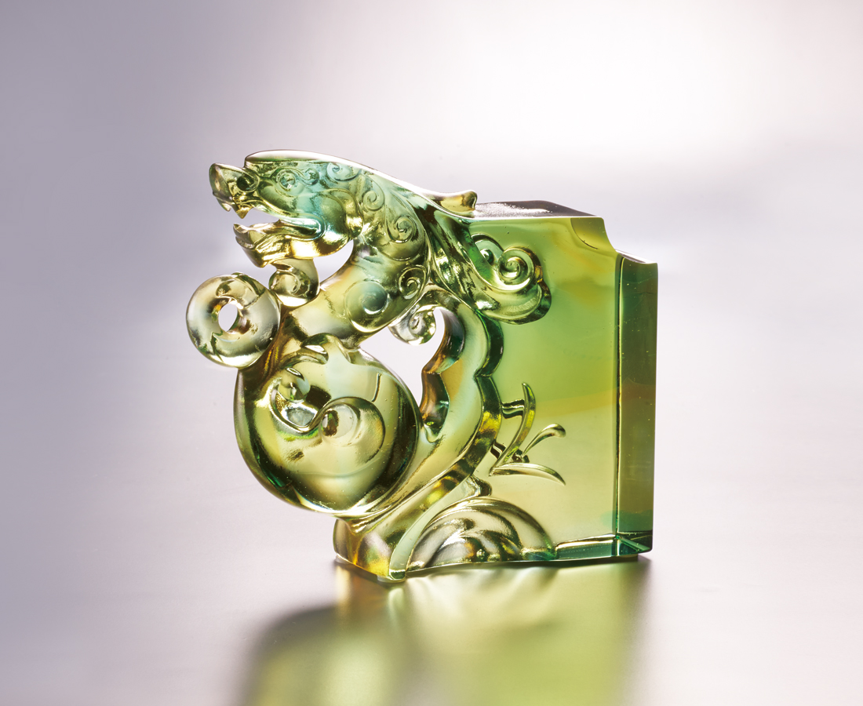
在風嘯中起身
不圖險中求勝
蜿蜒靈活
生機已在握中
風起 順勢而上
雲湧 乘運高飛
Queti - Tiger
The artists of the Qin and Han dynasties applied distorted and prolonged shapes on their artworks to show the dragon’s and tiger’s dynamics. Tittot, deriving from this idea, converts the traditional Queti shape into an elastic tiger-shaped carving. By integrating tittot’s skills with modern aesthetics, we endure a new life upon traditional oriental arts.

編號 | 1143868 | No | 1143868
名稱 | 虎勢高昇 | Name | Queti - Tiger
顏色 | 金青透 | Color | golden, cyan, clear
尺寸 | 11.5 * 3.1 * 9.8 | Size | 11.5 * 3.1 * 9.8
重量 | 0.53 | Weight | 0.53
限量 | O | Limited Edition | O
售價 | NT$ 5280 | Price | NT$ 5280
 | RMB$ 1180 |  | RMB$ 1180

