龍運亨通 | 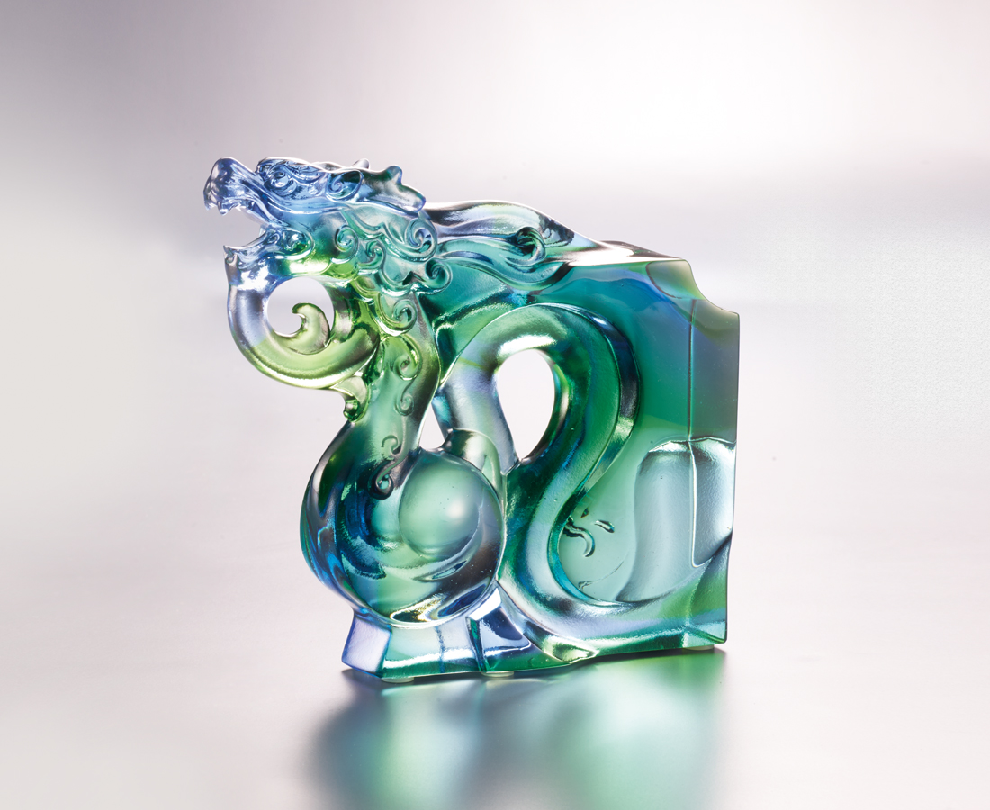
自雲海翻騰而起
高迎旭日 大氣吐吞
萬物逢春 氣運崢嶸
從智慧爭脫而出
仰望紫氣 前程似錦
青雲直上 處處亨通
Queti-Dragon
Tittot, combining the Chinese philosophy of the Five Elements “Wuxing” with Chinese architectural decoration “Queti,” creates a new phase of Chinese crystal glass. Dragon symbolizes the east, spring, and a new life: sweeping away the ill fortune, and bringing in a good start.

編號 | 1143867 | No | 1143867
名稱 | 龍運亨通 | Name | Queti-Dragon
顏色 | 藍綠透 | Color | blue, green, clear
尺寸 | 11.5 * 3.1 * 10.5 | Size | 11.5 * 3.1 * 10.5
重量 | 0.47 | Weight | 0.47
限量 | O | Limited Edition | O
售價 | NT$ 5280 | Price | NT$ 5280
 | RMB$ 1180 |  | RMB$ 1180

