龍行天下 | 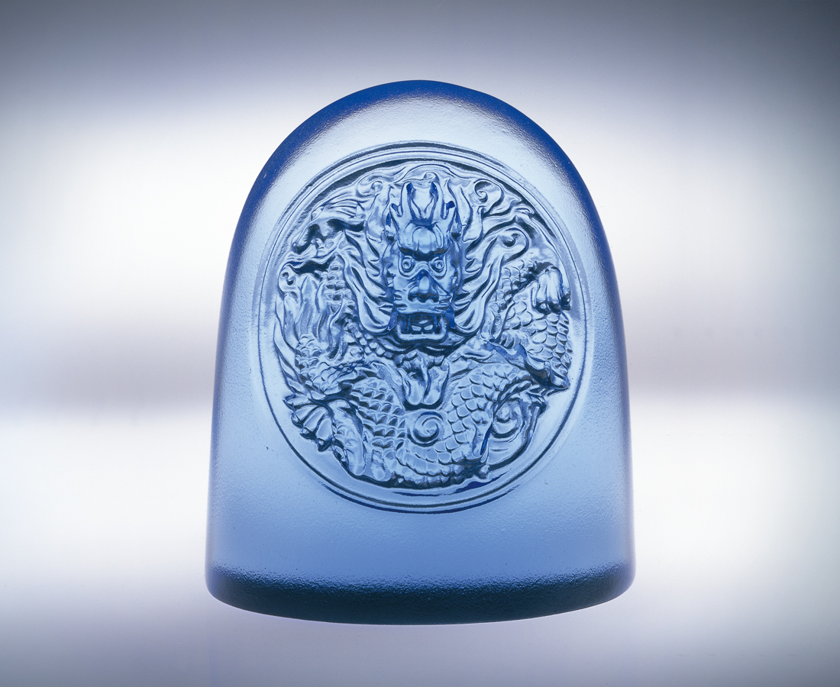
起心動念
一顆小種子
一番頂天立地的氣勢
一派全神貫注必勝的信心
一種神龍出海風馳電掣的行動
一場不出所料完美的成功
一路龍行天下的必然
一身好神氣
A Dragon Soaring in the World
An idea inspired in mind. A small seed An indomitable spirit and force A concentrated and definitely conquered confidence A kind of Magic Dragon-like action soaring out from the ocean It brings the blast and lighting stroke to take in action. An expected perfect success in the dragon mind, All the way the dragon has rescued the world. A really proud dragon from stern to stern.

編號 | 1142058 | No | 1142058
名稱 | 龍行天下 | Name | A Dragon Soaring in the World
顏色 | 藍／金 | Color | blue／orange
尺寸 | 3.6 * 5.5 * 6.4 | Size | 3.6 * 5.5 * 6.4
重量 | 0.26 | Weight | 0.26
限量 | X | Limited Edition | X
售價 | NT$ 2560 | Price | NT$ 2560
 | RMB$ 626 |  | RMB$ 626

