如意如龍 | 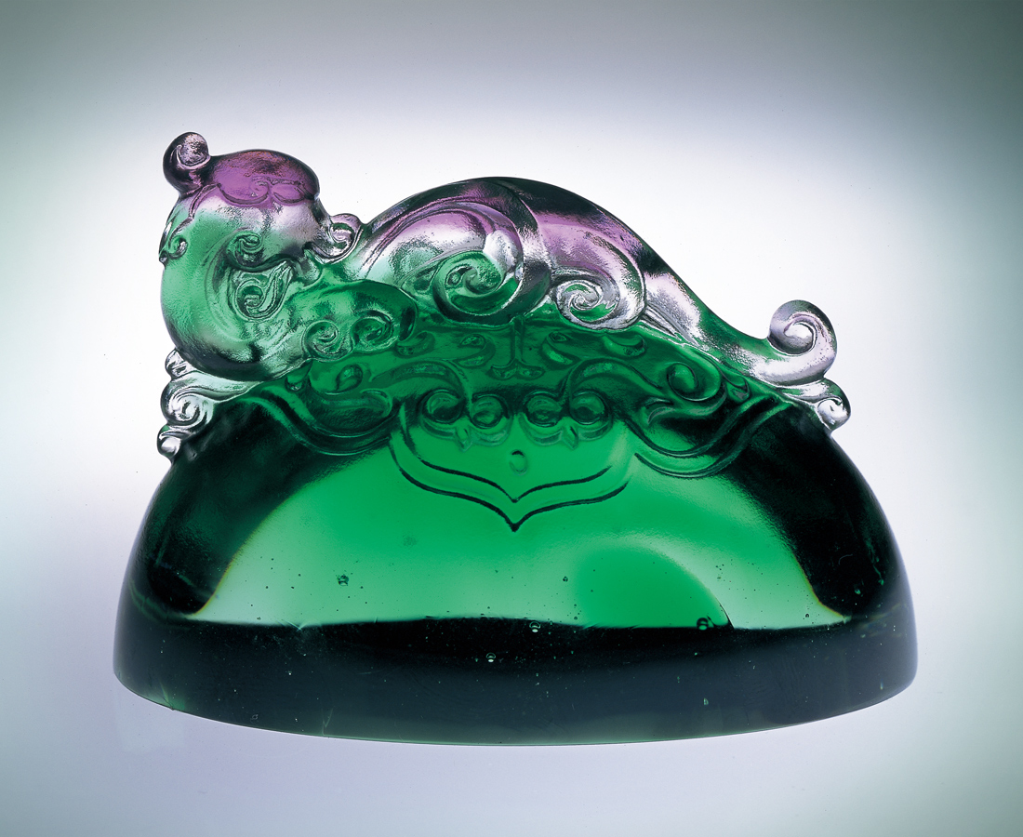
順著風起的動向
先得獨領風潮的優勢
乘著雲湧的澎湃
躍進無限可能的壯闊
洞悉的智慧 旺盛的雄心
鋪陳震古爍今的盛世
而耀如意如龍的光芒
As The Satisfied Dragon
Follow the movement of the breeze rising Firstly get the advantage of superb appearing Riding the surge of cloud thoroughly to pass And jump into the lasting range of universe Filling with best insight and aggressive ambition To encourage oneself in the future generation Surpassing ancients and amazing contemporaries To share lasting light of sparkling satisfied dragons

編號 | 1142056 | No | 1142056
名稱 | 如意如龍 | Name | As The Satisfied Dragon
顏色 | 紫綠透／藍金透 | Color | purple, green, clear／blue, golden, clear
尺寸 | 4 * 7 * 4.9 | Size | 4 * 7 * 4.9
重量 | 0.2 | Weight | 0.2
限量 | X | Limited Edition | X
售價 | NT$ 2860 | Price | NT$ 2860
 | RMB$ 706 |  | RMB$ 706

