志高氣爽 | 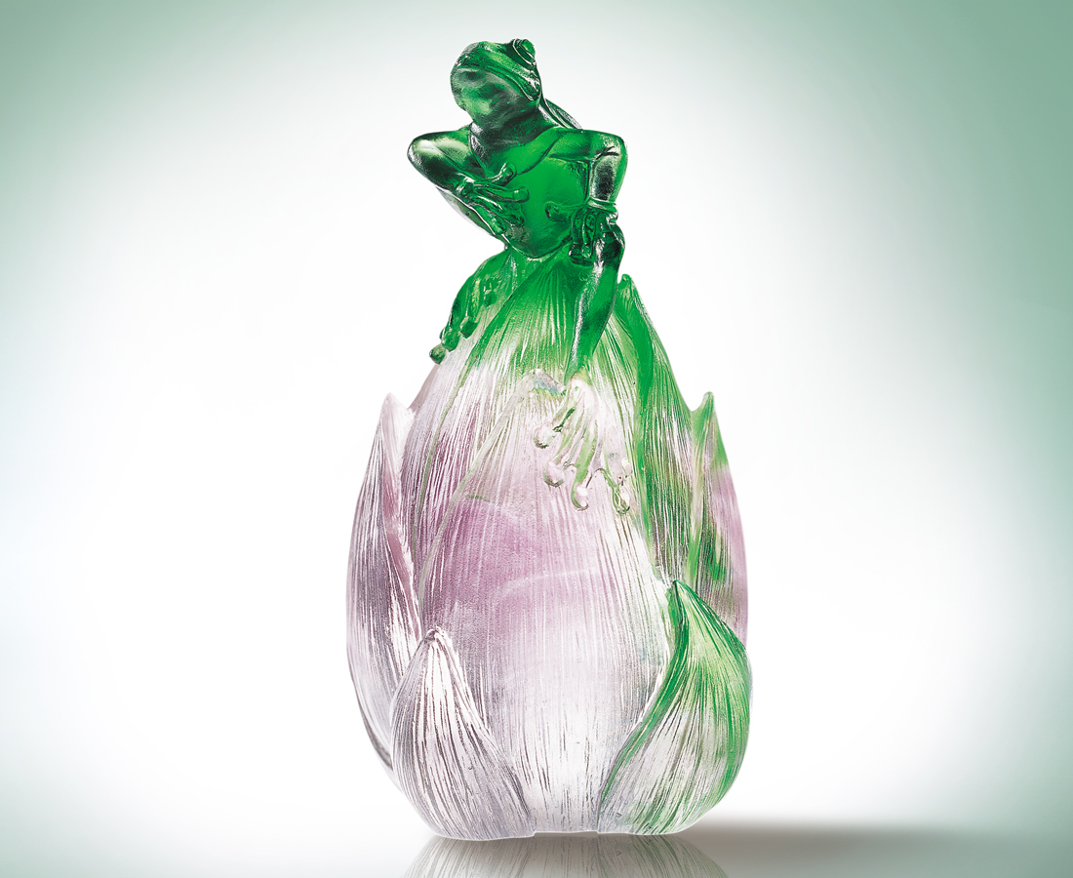
誰說青蛙只愛井底
選一個高 悠然望青天
擇一個低 清純做原則
冥想一揮 山巒向我走來
一聲令下 稻田一夜成熟
想像是美麗的征服
志氣是當下的出發
Lofty Aspirations and Straightforward Manner
Who says a frog wants to stay at the bottom of a well? Pick a high: gaze at the distant blue sky. Choose a low: set principles afresh. Meditate a bit: the mountain peaks are coming towards me; Give a single command: the rice has ripened overnight. Imagination is a wonderful conquest, Aspiration means starting right now.

編號 | 1119100 | No | 1119100
名稱 | 志高氣爽 | Name | Lofty Aspirations and Straightforward Manner
顏色 | 綠紫透／藍紫透 | Color | Green purple clear / Blue purple clear
尺寸 | 4.9 * 5.2 * 9.2 | Size | 4.9 * 5.2 * 9.2
重量 | 0.24 | Weight | 0.24
限量 | O | Limited Edition | O
售價 | NT$ 4160 | Price | NT$ 4160
 | RMB$ 966 |  | RMB$ 966

