高瞻遠矚 | 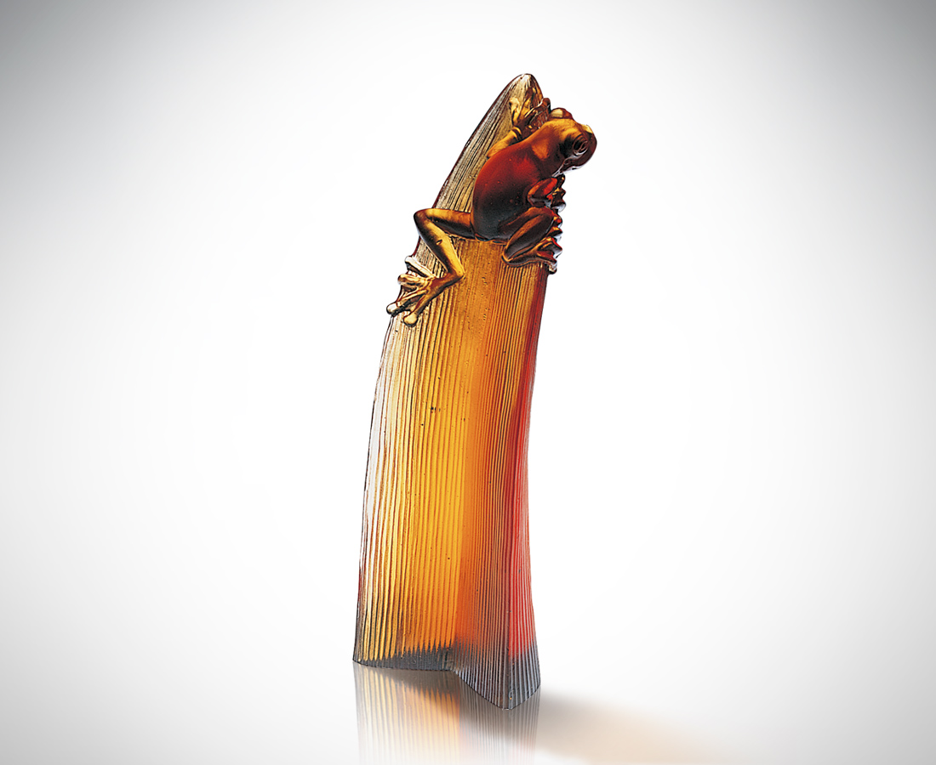
位高景闊
勢重權大
浩瀚全景 渺渺茫茫
模糊失真 紛擾不安
似有若無 焦點游移
看得全 看得淺
謹慎論斷 步步為營
就是高瞻遠矚
View From on High
From on high the vista is wide Power and authority Limitless scene Distant and vague Shadowy and unreal Chaotic and disturbed Now you see it, now you don‘t The focus moves Viewing the whole thing You see it imperfectly Decide with caution At every step consider with care The transcendental view

編號 | 1116041 | No | 1116041
名稱 | 高瞻遠矚 | Name | View From on High
顏色 | 琥透 | Color | amber, clear
尺寸 | 4 * 4.7 * 13 | Size | 4 * 4.7 * 13
重量 | 0.3 | Weight | 0.3
限量 | O | Limited Edition | O
售價 | NT$ 5680 | Price | NT$ 5680
 | RMB$ 1288 |  | RMB$ 1288

