平安有福 | 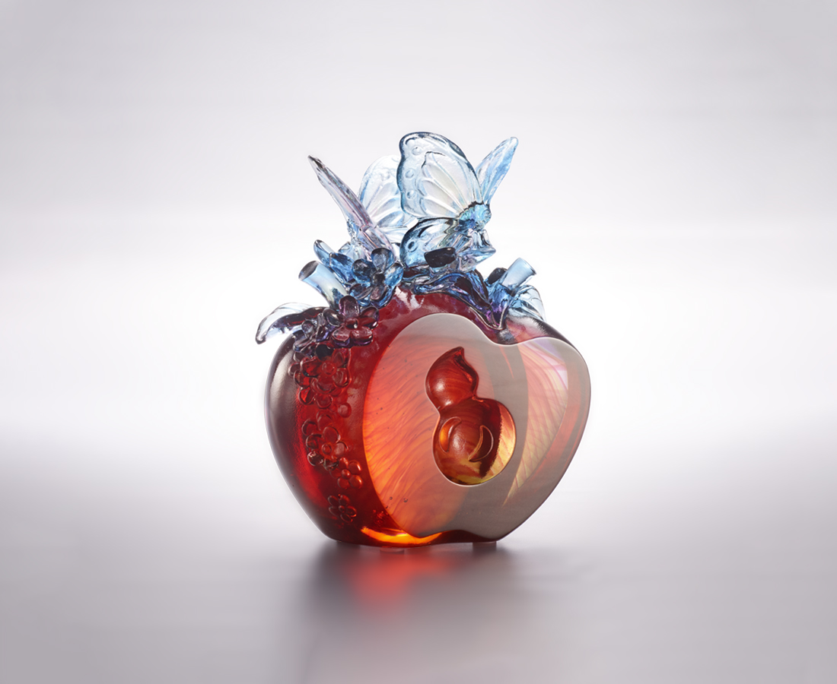
甘蜜引福 快活落腳
天地相伴 恬逸秩秩
春風百花漫 壎箎兩相和
平安 心自在
喜樂 左右來
Best Place to Stay
Chinese likes to use homonyms as symbols, therefore apples have the meaning of peace, and butterflies represent endless blessings. The moment butterflies set foot on the fragrant flowers and apples is not only pleasing to the eye, but also the most sincere blessing in Chinese culture.

編號 | 1113996 | No | 1113996
名稱 | 平安有福 | Name | Best Place to Stay
顏色 | 紫青紅琥透 | Color | purple, cyan, red, amber, clear
尺寸 | 10.5 * 6.3 * 13 | Size | 10.5 * 6.3 * 13
重量 | 1.0 | Weight | 1.0
限量 | X | Limited Edition | X
售價 | NT$ 5880 | Price | NT$ 5880
 | RMB$ 1400 |  | RMB$ 1400

