生機盎然 | 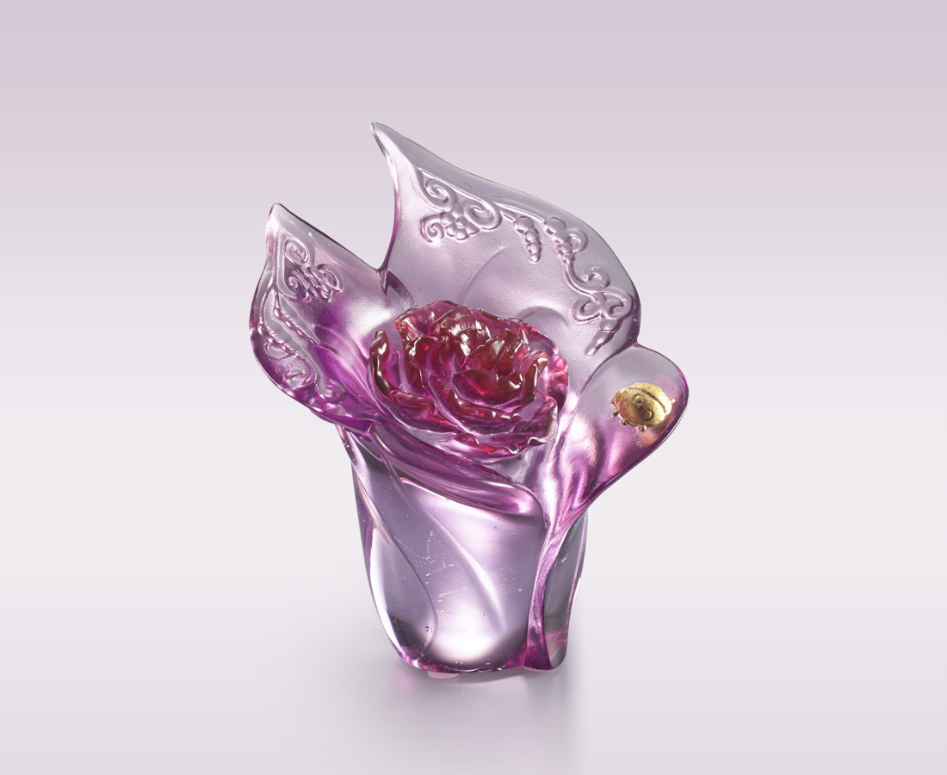
從一朵盛開的花
窺探宇宙孕育的秘密
一花一世界
一葉一從容
心中存希望
處處有生機
Vigorous Lease of Life
The artwork, with a blooming flower, depicts the process of the universe, from the separation of sky and land to the creation of human beings. The flower symbolizes the vigorous lease of life, and infinite hope.

編號 | 1113889 | No | 1113889
名稱 | 生機盎然 | Name | Vigorous Lease of Life
顏色 | 紫紅粉紅+金箔 | Color | fuchsia, pink + gilding
尺寸 | 9.5 * 8 * 11.3 | Size | 9.5 * 8 * 11.3
重量 | 0.5 | Weight | 0.5
限量 | O | Limited Edition | O
售價 | NT$ 5280 | Price | NT$ 5280
 | RMB$ 1180 |  | RMB$ 1180

