荷諧共鳴 | 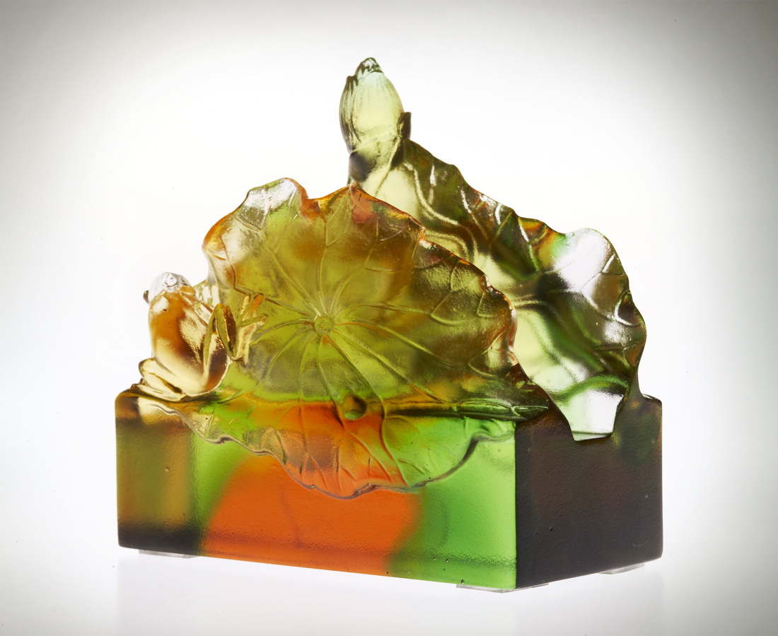
向前探
打聽你的蹤影
向上升
分享你的成就
不忘同心合力
帶來好事蓮連
Resonating Blooms
Leaning forward To seek your presence. Rising upward To share your accomplishments. Never forget that our joined efforts Bring forth ripples of resonating blooms.

編號 | 1112273 | No | 1112273
名稱 | 荷諧共鳴 | Name | Resonating Blooms
顏色 | 琥綠透 | Color | amber, green, clear
尺寸 | 3.9 * 7 * 6.9 | Size | 3.9 * 7 * 6.9
重量 | 0.24 | Weight | 0.24
限量 | X | Limited Edition | X
售價 | NT$ 2380 | Price | NT$ 2380
 | RMB$ 586 |  | RMB$ 586

