豐穰之冠 | 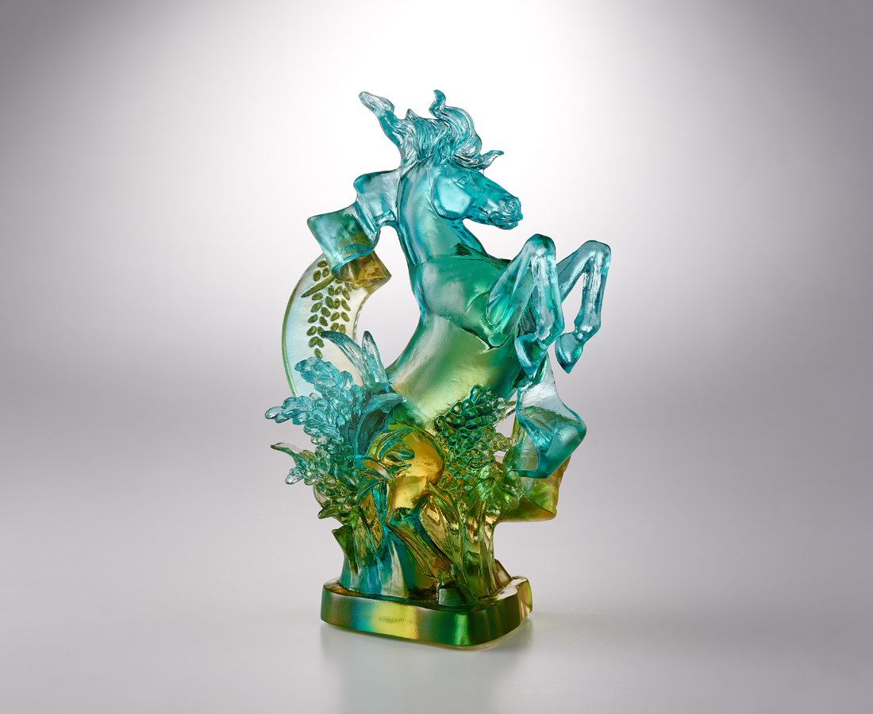
馳騁如風 躍起如弓
桂冠加冕 極景豐穰
每一里路皆是歷練
每一縷光皆為初衷
The Self-Assured Horse
The horse, seventh in the Chinese zodiac, has long been admired in Chinese culture and history. Its traits, spirit, and posture carry many positive meanings. Among them, the horse’s upright stance, steady gaze, and poised presence symbolize confidence and strength, standing firm like a mountain. In this design, a flowing ribbon symbolizing success weaves through the horse’s mane, forming a crown that reflects abundance and accomplishment.

編號 | 1104148 | No | 1104148
名稱 | 豐穰之冠 | Name | The Self-Assured Horse
顏色 | 金青透+金箔 | Color | 金青透+金箔
尺寸 | 9.5 x 7.2 x 15.8 | Size | 9.5 x 7.2 x 15.8
重量 | 0.55 | Weight | 0.55
限量 | O | Limited Edition | O
售價 | NT$ 8800 | Price | NT$ 8800
 | RMB$ 1980 |  | RMB$ 1980

