好奢華 | 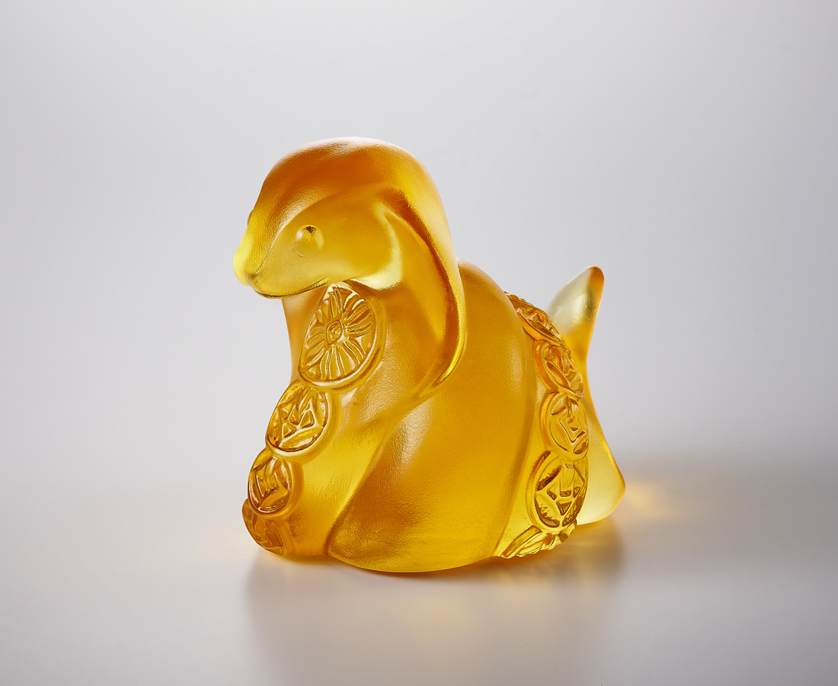
鋭目有智慧
盤據攢富貴
不只奢華一下
更要奢華一世
有我吐信
做蛇麼都好運
Chinese Snake of Fortune
The Chinese Snake is the sixth of the twelve Chinese Zodiac Signs, symbolizing the spirit of adaptability, flexibility, and perseverance. The snake is adorned with traditional Chinese coin motifs, symbolizing luck and fortune, adding an element of fun to daily life.

編號 | 1104124 | No | 1104124
名稱 | 好奢華 | Name | Chinese Snake of Fortune
顏色 | 金 | Color | Gold
尺寸 | 7.6 * 6 * 7.3 | Size | 7.6 * 6 * 7.3
重量 | 0.37 | Weight | 0.37
限量 | X | Limited Edition | X
售價 | NT$ 3980 | Price | NT$ 3980
 | RMB$ 880 |  | RMB$ 880

