卯喜 | 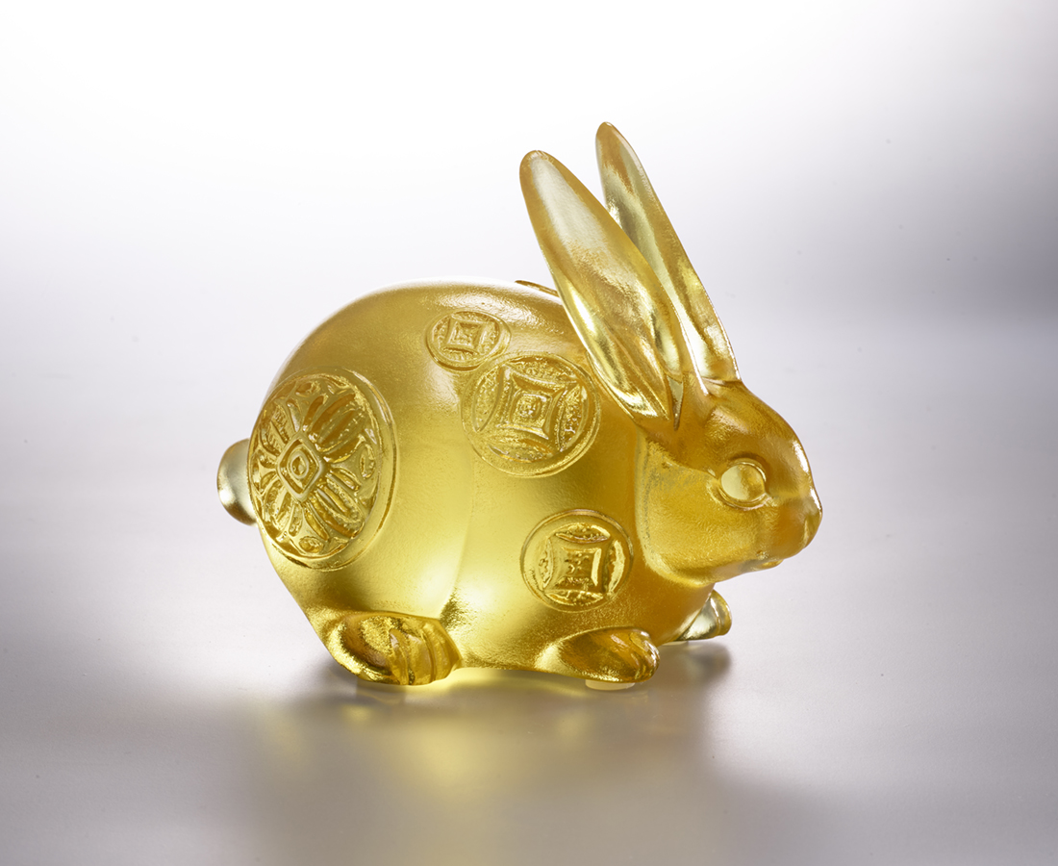
拭目以 帶財
傾耳而 聽牌
聚步致千里
積流成江海
卯足全力 喜笑盈腮
The Lucky Rabbit
In Chinese culture, the rabbit symbolizes an intelligent and resourceful personality because of its flexibility and keen eyesight and hearing. The rabbit's body is decorated with the traditional Chinese coin totem, which carries the symbolic meaning of praying for good fortune and attracting wealth, and also increases the pleasure of life.

編號 | 1103990 | No | 1103990
名稱 | 卯喜 | Name | The Lucky Rabbit
顏色 | 金 | Color | golden
尺寸 | 10.3 * 6.7 * 8.1 | Size | 10.3 * 6.7 * 8.1
重量 | 0.55 | Weight | 0.55
限量 | X | Limited Edition | X
售價 | NT$ 4080 | Price | NT$ 4080
 | RMB$ 980 |  | RMB$ 980

