寅大財 | 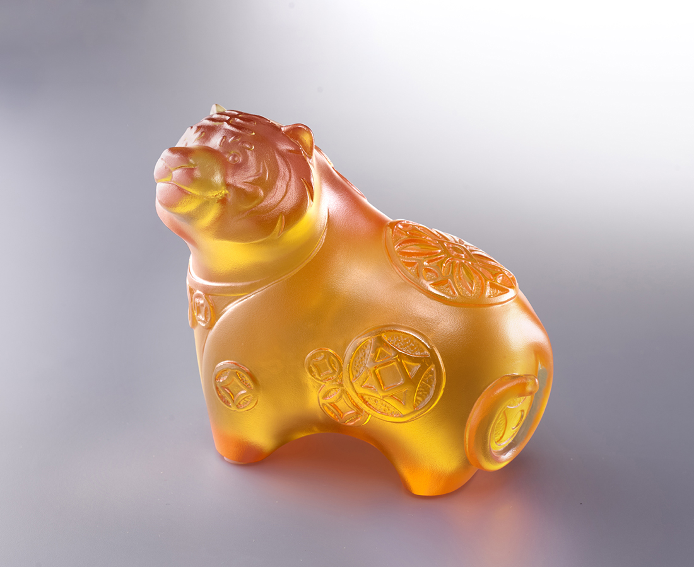
人見威嚴
不由敬稱一聲老
虎兒逍遙
自許洋洋得意
笑看招財進寶
Fortune Tiger
Tiger, one of the Chinese mythical beasts, symbolizes auspiciousness. Instead of the usually daring image, the work depicts the cute aspect of the tiger. The pattern of copper coins carved on the tiger conveys fortune and adds spirit to the image.

編號 | 1103959 | No | 1103959
名稱 | 寅大財 | Name | Fortune Tiger
顏色 | 琥 | Color | amber
尺寸 | 10.3 * 6.3 * 9 | Size | 10.3 * 6.3 * 9
重量 | 0.6 | Weight | 0.6
限量 | X | Limited Edition | X
售價 | NT$ 4280 | Price | NT$ 4280
 | RMB$ 950 |  | RMB$ 950

