鼠來寶 | 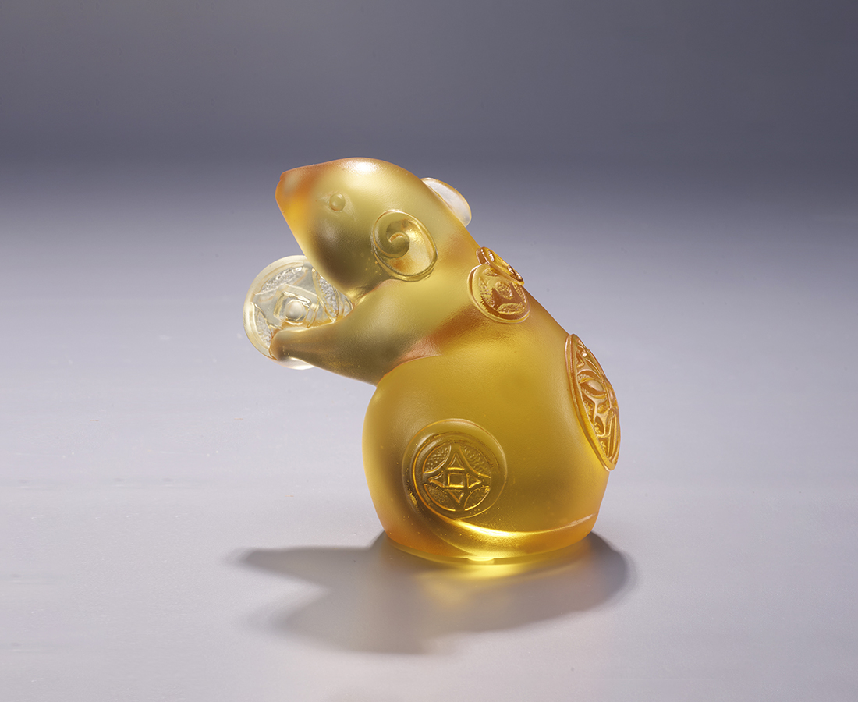
吱吱喳喳 鼠來寶
叮叮噹噹 錢滾滾
人喜逢盛世
金鼠兆豐年
Mouse holding coins
As the first of the Chinese zodiacs, the mouse symbolizes prosperity and fertility of family. The mouse, in addition, represents wealth. In the artwork, the mouse carries the coin with his hands, as if it is offering it. The peony engraved on the mouse’s body adds to the sense of auspiciousness.

編號 | 1103877 | No | 1103877
名稱 | 鼠來寶 | Name | Mouse holding coins
顏色 | 金 | Color | golden
尺寸 | 9.4 * 6.4 * 9 | Size | 9.4 * 6.4 * 9
重量 | 0.5 | Weight | 0.5
限量 | X | Limited Edition | X
售價 | NT$ 3980 | Price | NT$ 3980
 | RMB$ 890 |  | RMB$ 890

