諸事大吉 | 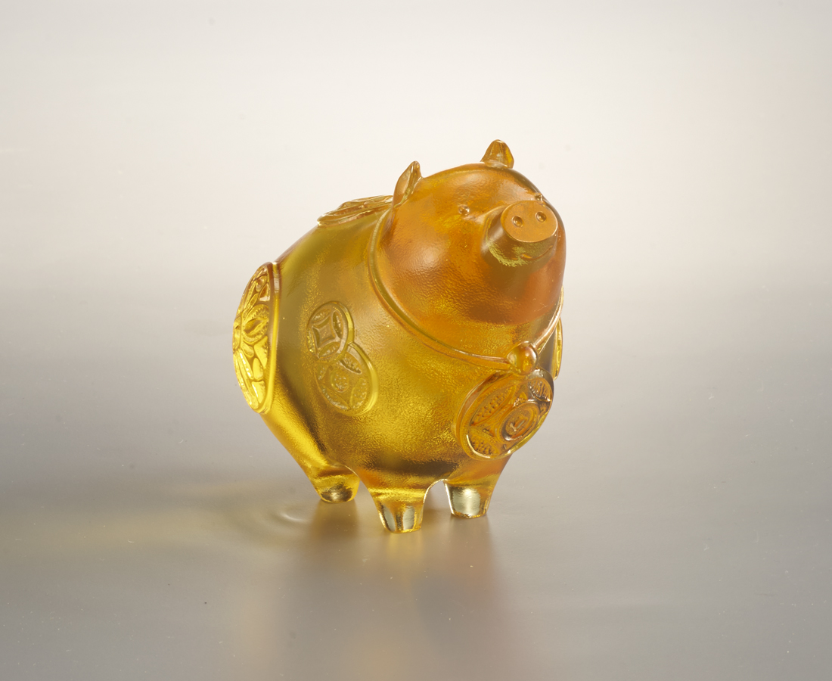
大富有容
抬頭向錢
豬肥家業盛
春好福源長
The Propitious Pig
In Chinese culture, the pig embodies wealth and blessings. The coin design on the pig withal represents fortune and prosperity.

編號 | 1103840 | No | 1103840
名稱 | 諸事大吉 | Name | The Propitious Pig
顏色 | 金 | Color | golden
尺寸 | 9.2 * 6 * 8.1 | Size | 9.2 * 6 * 8.1
重量 | 0.5 | Weight | 0.5
限量 | O | Limited Edition | O
售價 | NT$ 4260 | Price | NT$ 4260
 | RMB$ 880 |  | RMB$ 880

