汪旺來富 | 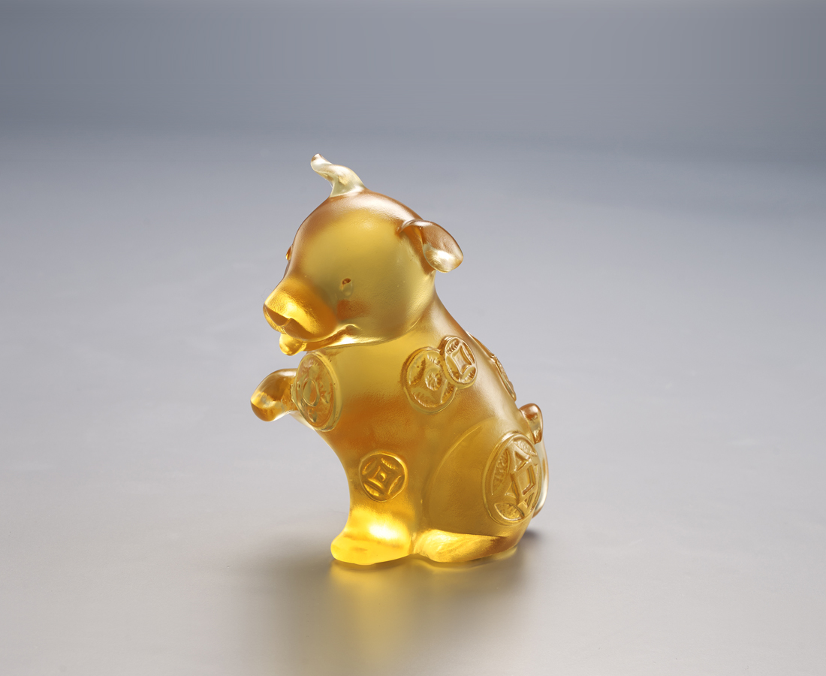
守護自己的幸福
仰望眼前的機會
對未來鍥而不捨
勇敢伸手
運也旺旺
人也興旺
Lucky Money Dog
Tittot takes the Oriental idea that “dogs bring wealth” as the subject. With an adorable expression and an extended front paw, as if every opportunity and good fortune is seized.

編號 | 1103789 | No | 1103789
名稱 | 汪旺來富 | Name | Lucky Money Dog
顏色 | 金 | Color | golden
尺寸 | 8.6 * 5.5 * 9.6 | Size | 8.6 * 5.5 * 9.6
重量 | 0.4 | Weight | 0.4
限量 | X | Limited Edition | X
售價 | NT$ 3980 | Price | NT$ 3980
 | RMB$ 880 |  | RMB$ 880

