如獲至寶 | 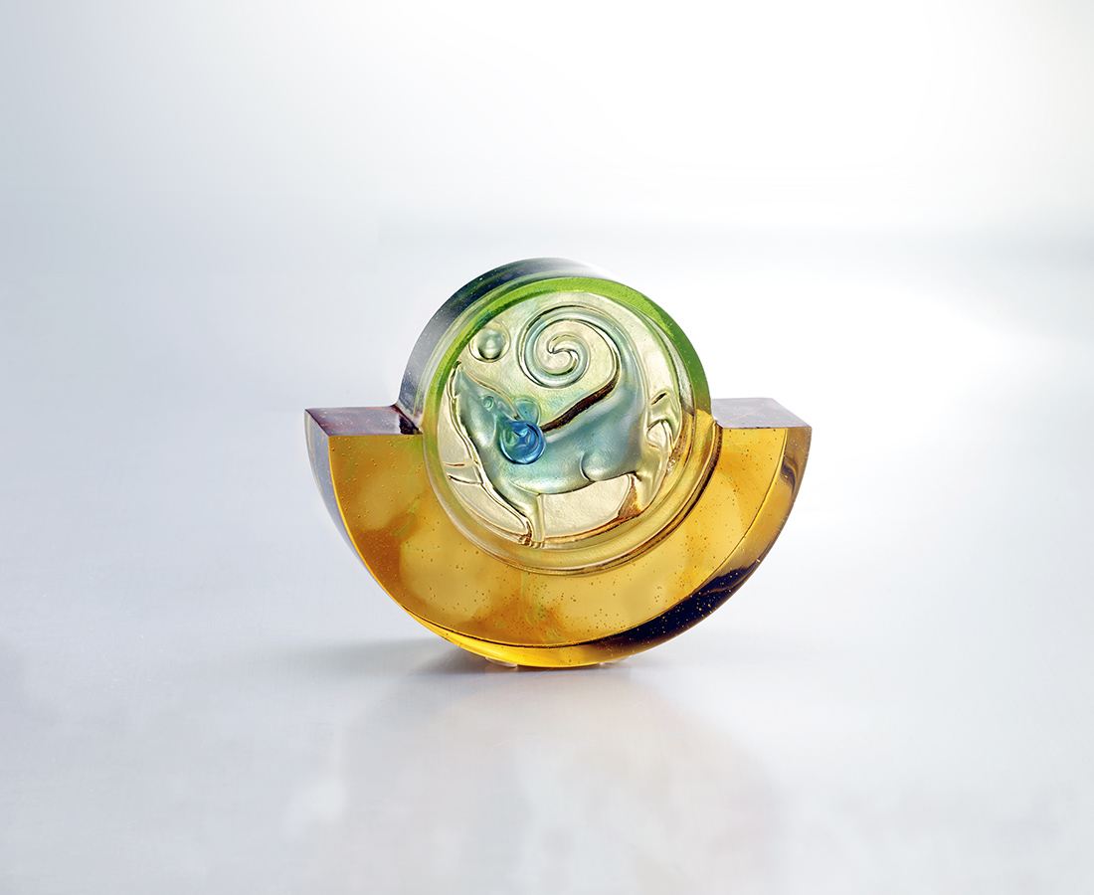
每個小小腳步
都是通向成功的一大步
轉動生命的大圓
奔向如獲至寶的豐收
Like Finding Priceless Treasure
Taking as the subject a mouse running within an ingot of gold, this piece pronounces a blessing on those who put forth effort; a wish that they may accumulate great wealth.

編號 | 1103779 | No | 1103779
名稱 | 如獲至寶 | Name | Like Finding Priceless Treasure
顏色 | 金琥藍綠 | Color | golden, amber, blue, green
尺寸 | 9.8 * 2.9 * 7.9 | Size | 9.8 * 2.9 * 7.9
重量 | 0.37 | Weight | 0.37
限量 | X | Limited Edition | X
售價 | NT$ 3880 | Price | NT$ 3880
 | RMB$ 860 |  | RMB$ 860

