五吉羊 | 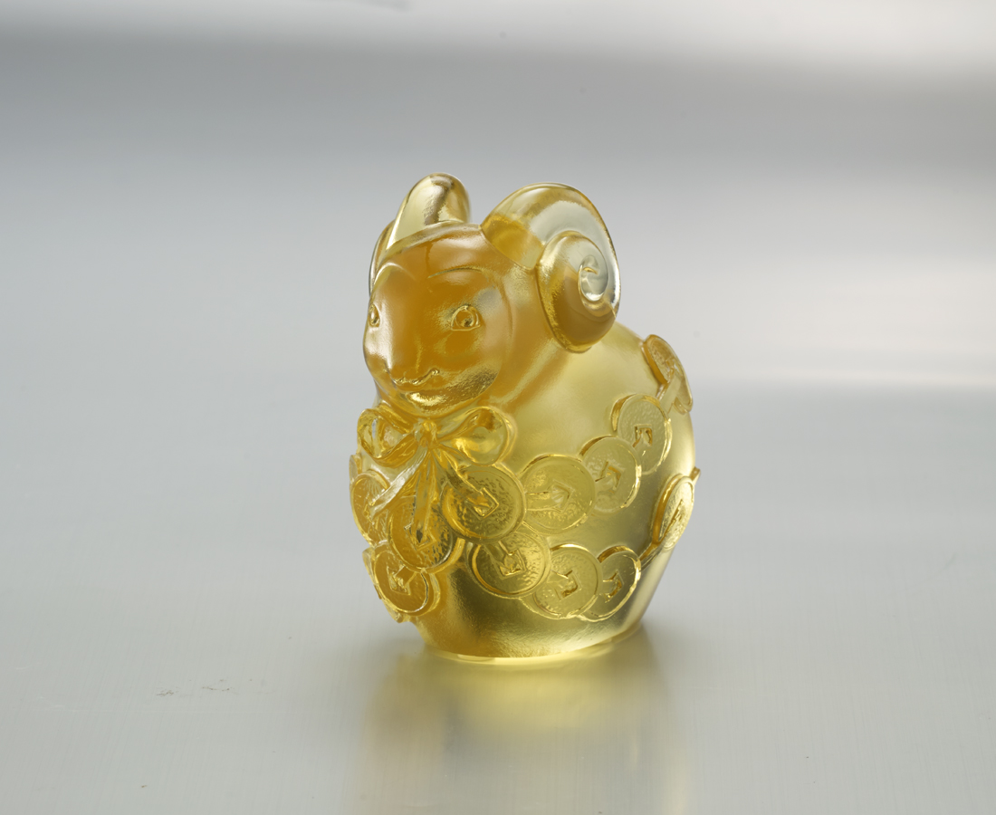
活的自信 磊落開朗
結一身善緣具足
用心迎接 積極樂觀
披一生富貴榮華
Lucky Sheep
The smiling little sheep is so adorable And its fur coiled into coins of fortune Tittot expresses on this artwork that with optimistic And confident attitude, one would bring beauty and Happiness in to his/her life.

編號 | 1103526 | No | 1103526
名稱 | 五吉羊 | Name | Lucky Sheep
顏色 | 金 | Color | golden
尺寸 | 8.6 * 6 * 8.6 | Size | 8.6 * 6 * 8.6
重量 | 0.65 | Weight | 0.65
限量 | X | Limited Edition | X
售價 | NT$ 3880 | Price | NT$ 3880
 | RMB$ 860 |  | RMB$ 860

