一路高昇 | 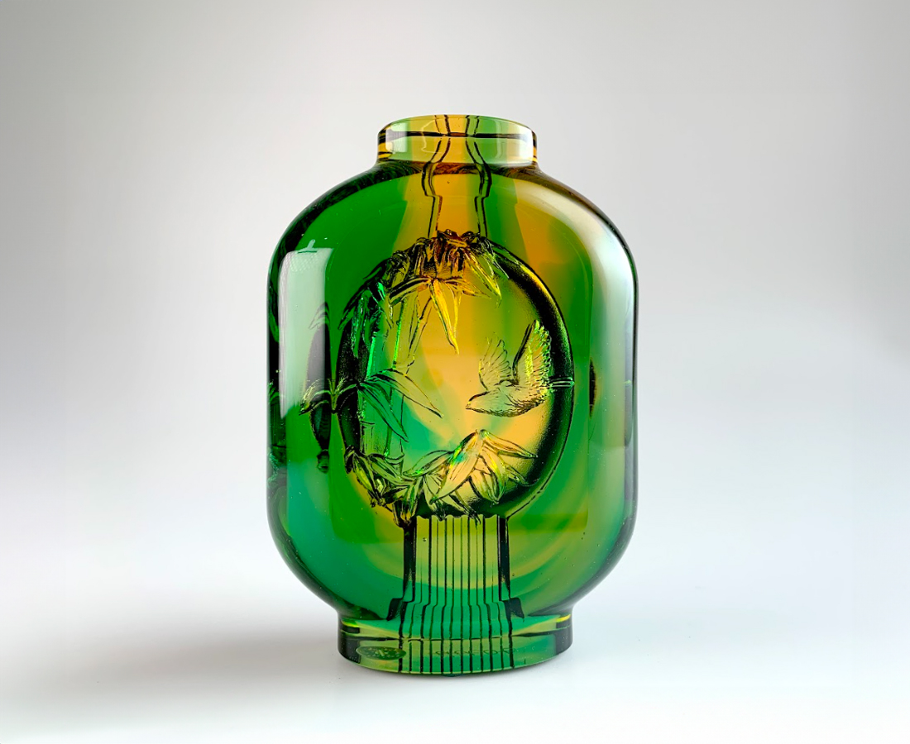
虛心 能容四海
有節 不卑不亢
一路高昇
點亮功成名就的階梯
Endless Progress
A bamboo is hollow yet grows steadily, symbolizing humility and progress. Based on the design concept, the combination of lantern and bamboo represents integrity and humility. This artwork emits a gentle luster under the light, which signifies great success achieved through humility and perseverance.

編號 | 1103360 | No | 1103360
名稱 | 一路高昇 | Name | Endless Progress
顏色 | 金綠透 | Color | golden,green, clear
尺寸 | 9.1 * 4.1 * 12.4 | Size | 9.1 * 4.1 * 12.4
重量 | 0.82 | Weight | 0.82
限量 | X | Limited Edition | X
售價 | NT$ 5280 | Price | NT$ 5280
 | RMB$ 1180 |  | RMB$ 1180

