綵結富貴 | 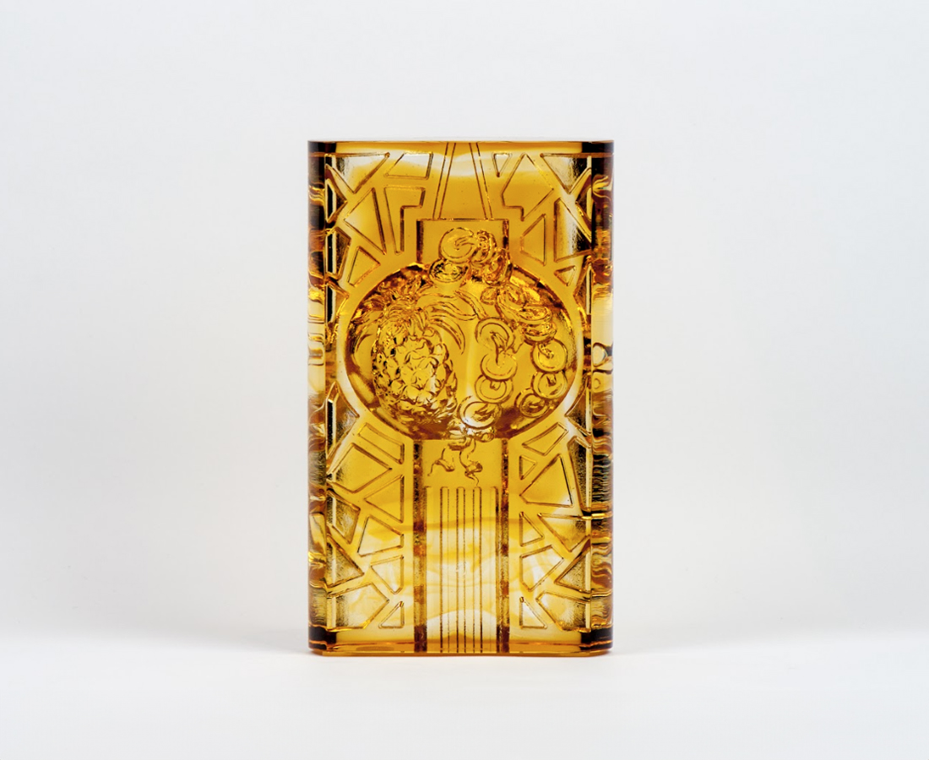
成熟 運勢興旺
勤耕 滿溢豐盈
豐盛榮華
點亮富貴萬年的光彩
The Colorful Knot of Wealth
The designer combines the figures of lantern, coins and pineapple to symbolize light, wealth and good luck. This artwork emits a gentle luster under the light, which signifies great aspirations, eternal fortune and endless luck for everyone.

編號 | 1103359 | No | 1103359
名稱 | 綵結富貴 | Name | The Colorful Knot of Wealth
顏色 | 琥透 | Color | amber,clear
尺寸 | 8 * 3.9 * 13.5 | Size | 8 * 3.9 * 13.5
重量 | 0.95 | Weight | 0.95
限量 | X | Limited Edition | X
售價 | NT$ 5250 | Price | NT$ 5250
 | RMB$ 1180 |  | RMB$ 1180

