如意有喜 | 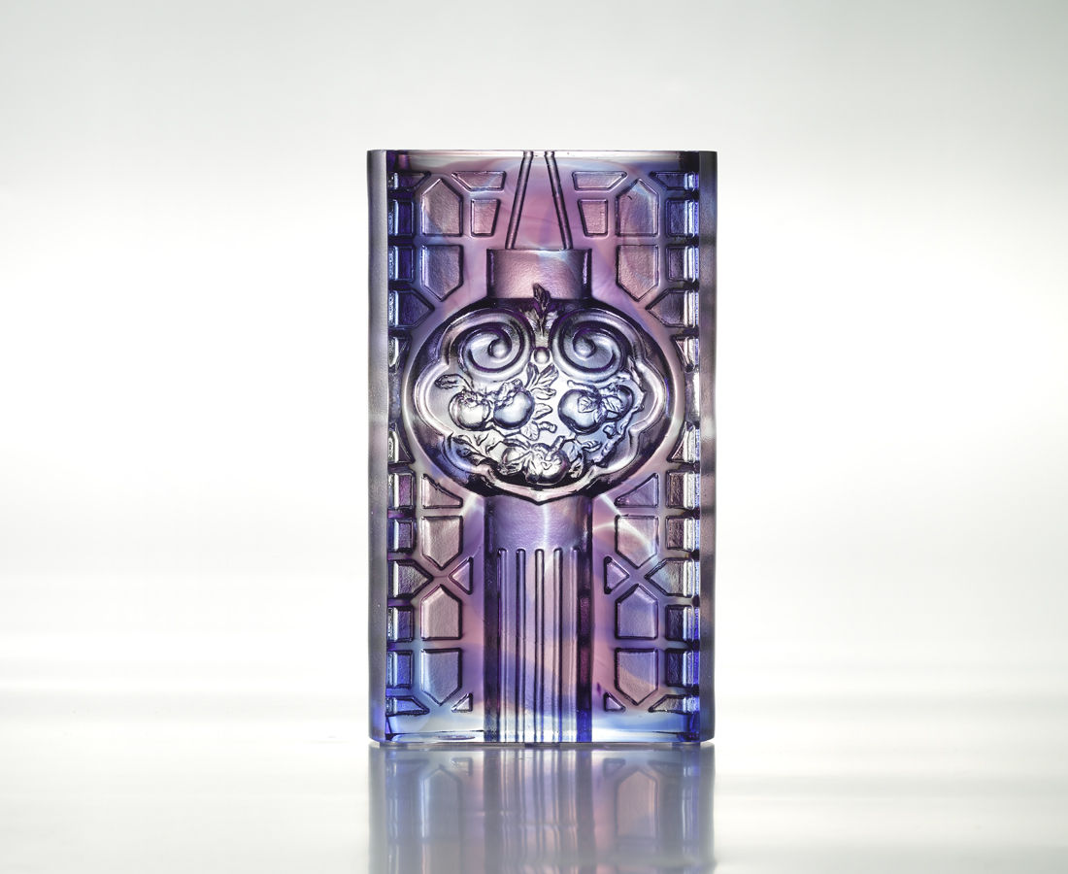
從容 得心應手
樂觀 百福自臻
吉祥如意
點亮喜事連連的預兆
Great Aspirations
The designer combines the figures of lantern, lucky patterns and persimmon to symbolize light and effortlessness. This artwork emits a gentle luster under the light, which signifies great aspirations and wellbeing for everyone in the future.

編號 | 1103358 | No | 1103358
名稱 | 如意有喜 | Name | Great Aspirations
顏色 | 藍紫透 | Color | blue,purple,clear
尺寸 | 8 * 3.9 * 13.5 | Size | 8 * 3.9 * 13.5
重量 | 0.95 | Weight | 0.95
限量 | X | Limited Edition | X
售價 | NT$ 4980 | Price | NT$ 4980
 | RMB$ 1110 |  | RMB$ 1110

