彩燈添壽 | 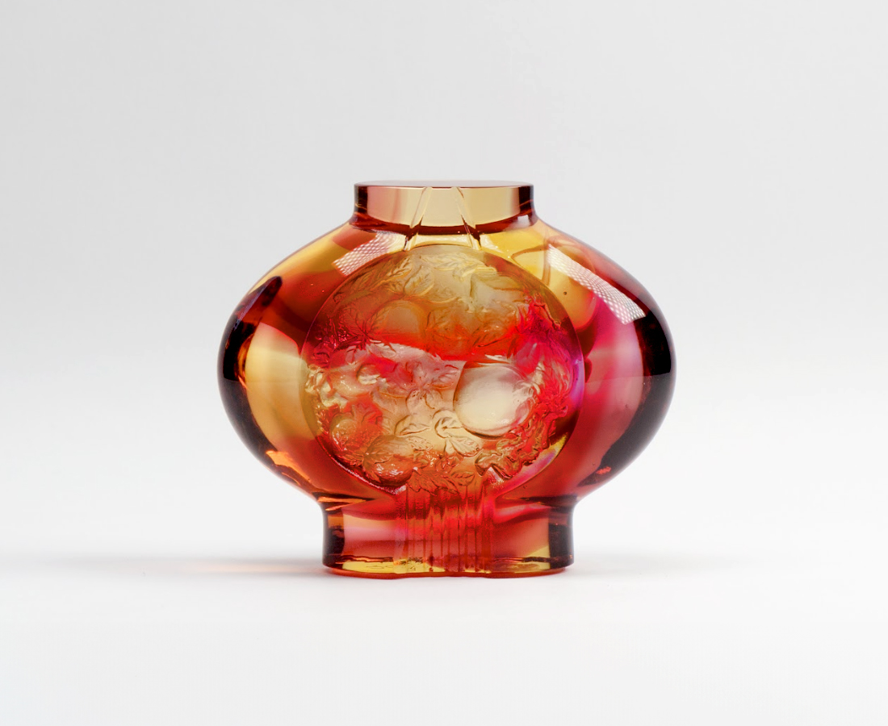
知足 持盈保泰
應時 生生不息
安康長壽
點亮闔家平安的祈願
The Longevity Lantern
The designer combines the figures of lantern and peaches to symbolize light and longevity. This artwork emits a gentle luster under the light, which signifies a bright future and longevity for everyone.

編號 | 1103357 | No | 1103357
名稱 | 彩燈添壽 | Name | The Longevity Lantern
顏色 | 琥紅透 | Color | amber,red,clear
尺寸 | 10.4* 4 * 8.7 | Size | 10.4* 4 * 8.7
重量 | 0.51 | Weight | 0.51
限量 | X | Limited Edition | X
售價 | NT$ 4680 | Price | NT$ 4680
 | RMB$ 1050 |  | RMB$ 1050

